Ani's GatewayGeo Progress

# Monday 22/10/03

Today we view most of the ClimateData.ca how-to videos, especially Topic 5 on data access. We’re looking for average hourly wind speed data for New Brunswick and Nova Scotia. If we find it we’ll download data for the days that Fiona spent in each province. Over the next two days we will do a simple data transformation (cube the wind speeds) and plot regions where estimated cumulative high wind energy was delivered using a color code to show magnitudes.

I found station data. I picked Cape Breton. I downloaded it from this link, selecting starting a day before Fiona and ending a day after Fiona. <https://climatedata.ca/download/#station-download>

# Wednesday 22/10/05

I will follow the QGIS tutorial to add layers from MSC Open Data. Then they will try to download layers for New Brunswick and Nova Scotia and make maps that they will screenshot and add to this Google Doc.

I followed the tutorial and learned how to add WMS/WMTS data which is simply accessing a URL.

I added WMS/WMTS data which access data from the URL of the geospatial web service. I did wind in Nova Scotia. I couldn’t find hurricane Fiona data.

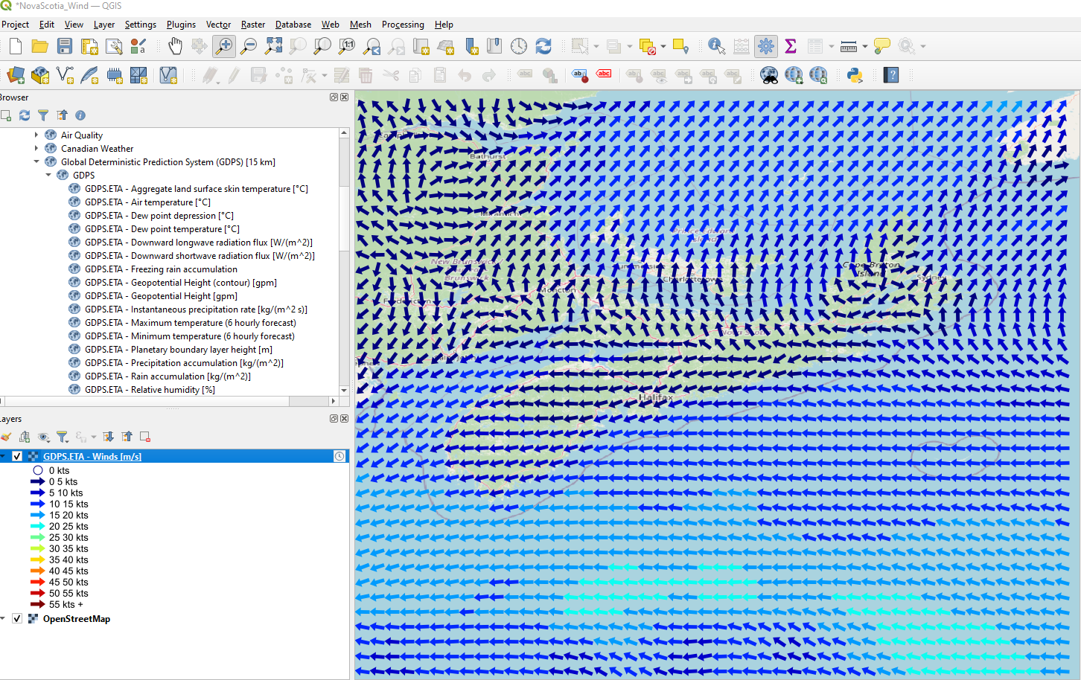

# Thursday 2022/10/06

Me and my twin sister Lili think we have accessed model data, not actual weather data. Looks like we’ll need a little coaching from Jeff about where and how to access weather data in formats and by mechanisms we either didn’t learn at COGS (data were always provided to us) or can’t recall.

Today we go back into MSC Open Data and check out the “Canadian Weather” directory to see what we can access and how to access it. Check out this URL: <https://api.weather.gc.ca/collections/swob-realtime>

I looked at these links and still couldn’t not find a way to download data.

Surface Weather and Marine Observation Markup Language (SWOB Met-ML) by station in XML format

<https://eccc-msc.github.io/open-data/msc-data/obs_station/readme_obs_insitu_swobdatamart_en/>

Surface Weather Observation XML (SWOB-XML) -Client User Guide

<https://collaboration.cmc.ec.gc.ca/cmc/cmos/public_doc/msc-data/obs_station/SWOB-ML_Product_User_Guide_e.pdf>

# Index of /observations/swob-ml

<https://dd.weather.gc.ca/observations/swob-ml/>

Surface Weather Observations

<https://api.weather.gc.ca/collections/swob-realtime/items?f=html&limit=10&startindex=0>

# Tuesday 2022/10/11

I did Three web layers. I learned how to access data layers from the internet. I did it starting at this link. <https://eccc-msc.github.io/open-data/msc-data/readme_en/#meteorological-service-of-canada-open-data>

I then clicked on links there and they led me to some web layer links I added to QGIS.

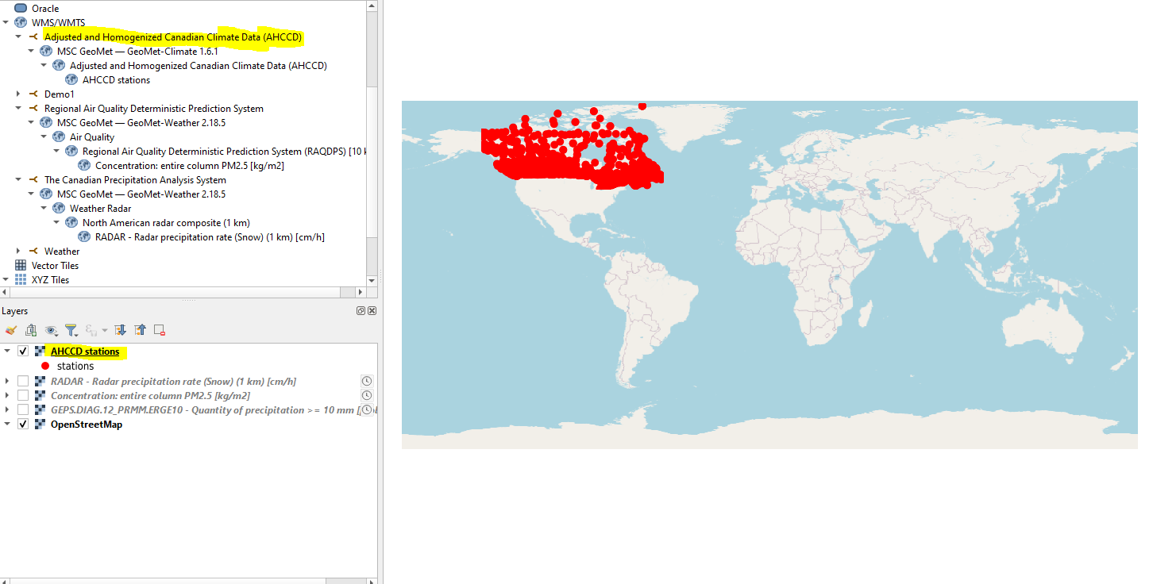

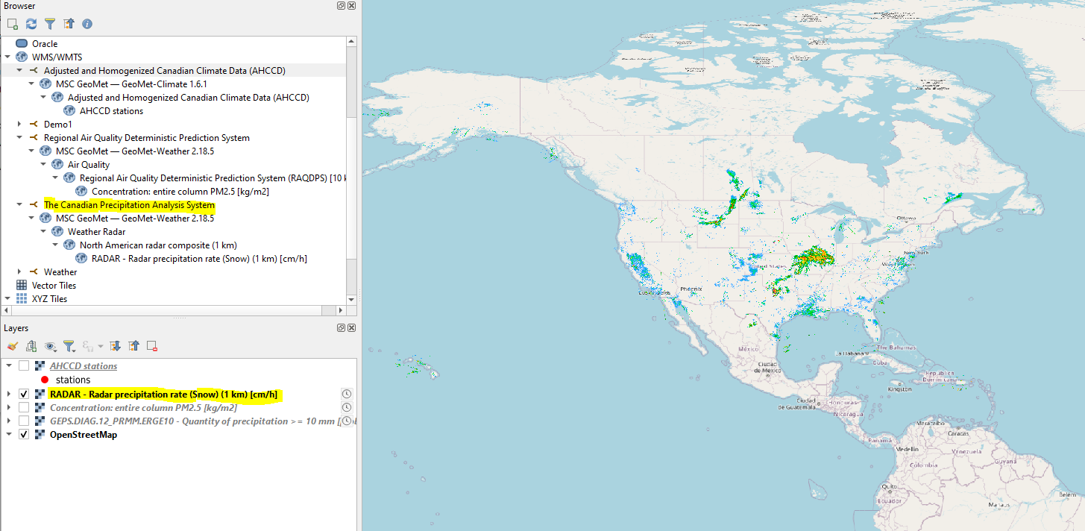

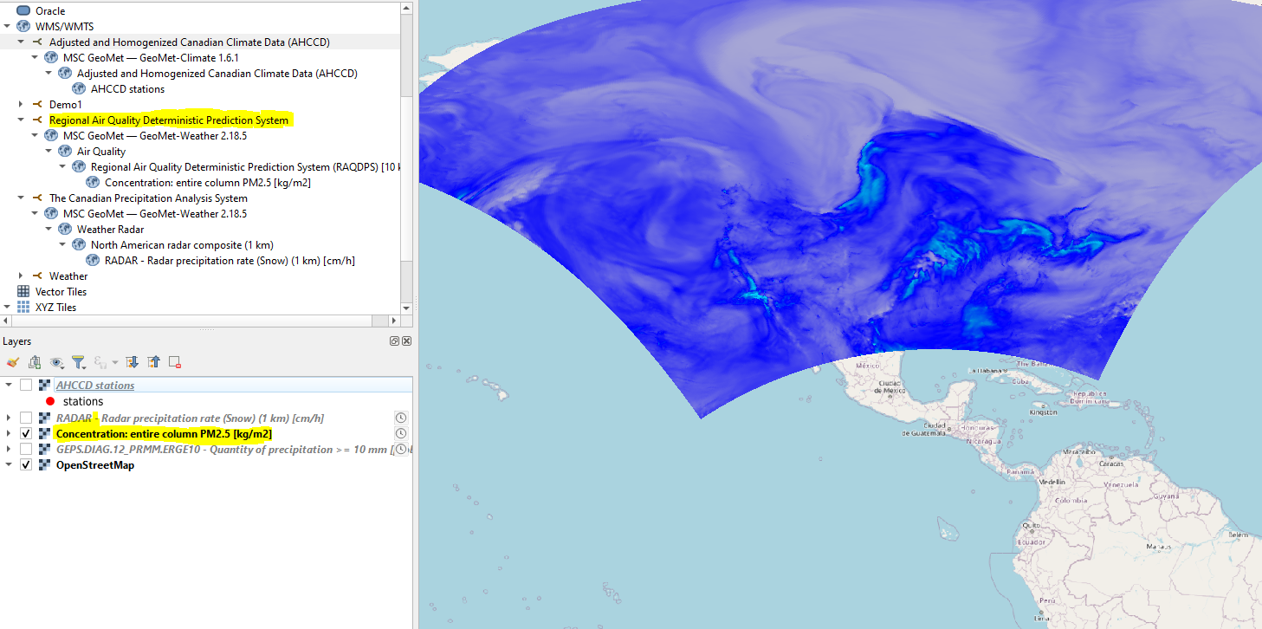

# Wednesday 22/10/12

Great work getting QGIS access! Today let’s try to do the same thing with ArcGIS Pro. We also need to zoom in on Nova Scotia and New Brunswick in either app and see if we can find data from the Fiona window. If we can map windspeed, that would be cool.

My ArcGIS account was not authorized to work on ArcGIS Pro.

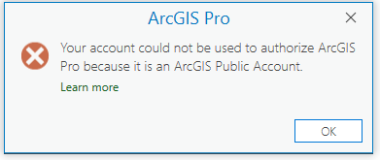

I’ll Try to zoom into Nova Scotia and look to find data from the Fiona time window Sept 23 to Sept 24. .

Web Layer DCS (Annual)- Projected average change in statistically downscaled maximum temperature for 2081-2100 (50th percentile)

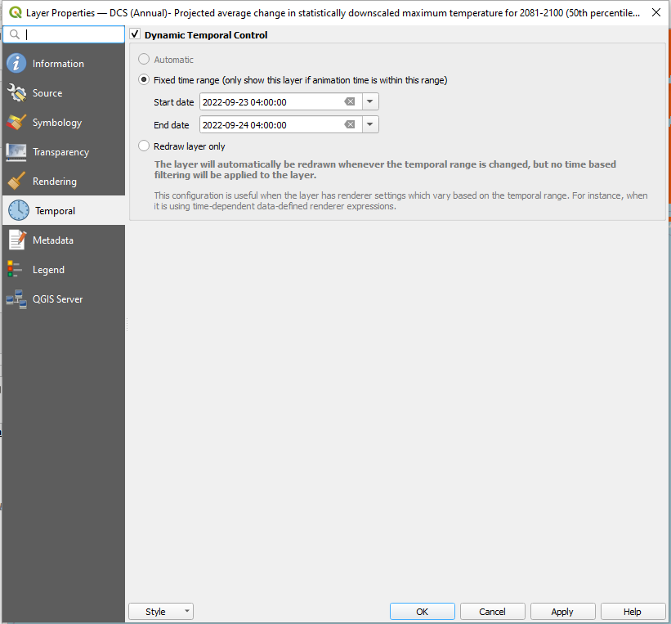

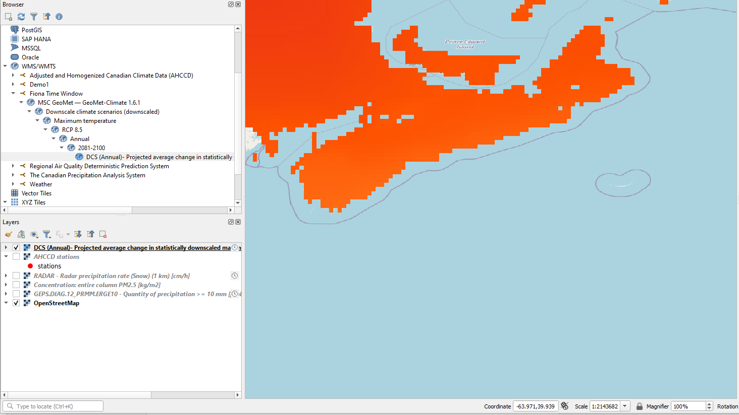

# Thursday 22/10/13

I need to authorize Esri apps for my computer. I need to find *historical* weather data for NS/NB, not models of projected future weather conditions.

I tested data at this link <https://api.weather.gc.ca/> and it didn’t work. When I added one of the links <https://api.weather.gc.ca/collections/climate:cmip5:projected:seasonal:absolute/coverage?f=json>

to WMS in QGIS, it didn’t load the layer.

I went to this link <https://eccc-msc.github.io/open-data/msc-data/climate_cmip5/readme_cmip5_en/> and there was no data I was looking for. When I clicked on the links, it went to the government website for api weather and I knew it wouldn’t work because I tried it in the previous link above.

I found the data at this link, but it contained up to the year 2005. <https://eccc-msc.github.io/open-data/msc-geomet/readme_en/>

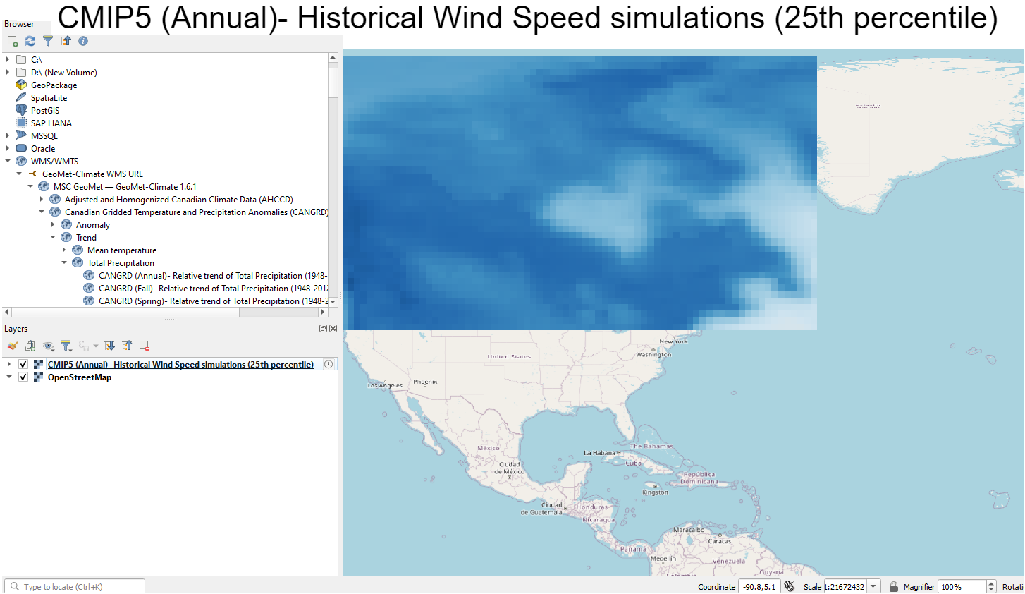

# Monday 22/10/17

We are going to try to collect hourly weather data from Nova Scotia and New Brunswick weather stations for the 48 hour period that Fiona spent in the two provinces. We will also need boundaries around the weather stations that set the extent of each weather station collection area. Our present target is average hourly wind speed, though we may also collect wind speed peaks and minimums and all other hourly data.

If we can access hourly wind speed as CSV data we will load them into a spreadsheet and compute the cube of each data point because wind energy is proportional to the cube of wind speed and then compute cumulative RMS proportional energy for each weather station. We will then create maps of 48 hr cumulative wind energy by weather station boundary and color code them by intensity. If we can find satellite image data for the 48 hr periods we will overlay the “wind energy” maps on the satellite maps to see if the destruction matches the wind energy patterns.

Today I will search for the data we want using Jeff’s suggestions ([link](https://docs.google.com/document/d/1Qcau3nb8XEcfJTdcd3sDkSXcNsx1QdCFHpiTeVlihs8/edit) to his Google Doc) and Emilia’s email notes.

I first searched “nova scotia hourly wind speed” on Dataset and got this result <https://datasetsearch.research.google.com/search?src=0&query=novia%20scotia%20hourly%20wind%20speed&docid=L2cvMTFqbl9kNjN6NQ%3D%3D> and clicked here in the result page <https://data.wu.ac.at/schema/www_data_gc_ca/YmQ5N2YyMmYtNGEzOC01ZWM5LTk3ZTEtNjE0NDUxZDc2MjI5> yet no WMS and couldn’t find a way to to put it in QGIS.

I also went here <https://maps.canada.ca/en/index.html> and clicked [gcgeo.gc.ca](http://gcgeo.gc.ca/) (government network) and the link didn’t work. Here’s a screenshot. 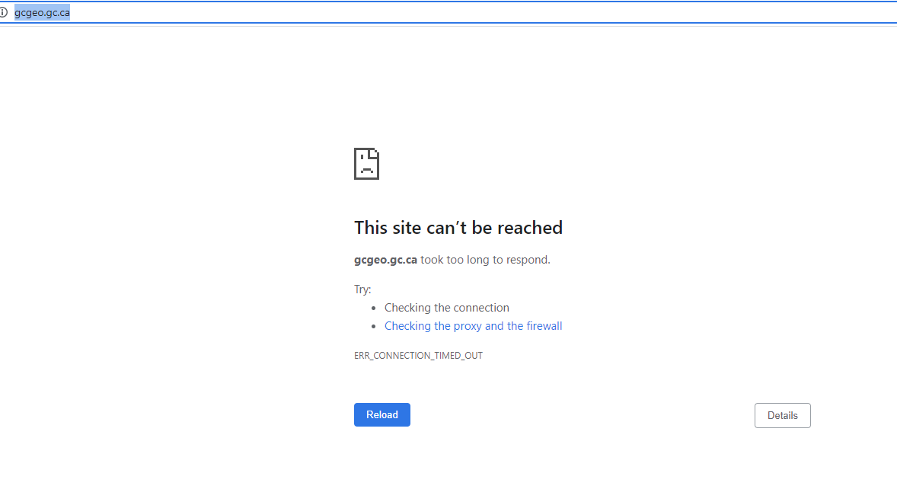

I also clicked on [Open Maps](https://open.canada.ca/en/open-maps) and searched wind speed and picked [Homogenized Surface Wind Speed (AHCCD)](https://open.canada.ca/data/en/dataset/fe8cbdac-c414-4dc9-8845-202111726104) from the results. I then picked AHCCD Annual and then I put this [link](https://geo.weather.gc.ca/geomet-beta/features/collections/ahccd-annual) into QGIS and it didn't work despite being WFS.

# Tuesday 22/10/18

Today we will try to download [hourly CSV data for NS weather stations](https://climate.weather.gc.ca/historical_data/search_historic_data_e.html) during the Fiona “window” (you will jointly define that window). If possible we will find a bulk download method. Otherwise we will select NS weather stations that “experienced” Fiona and download the data day by day, station by station.

I downloaded all 56 items from page 1 of this [link](https://climate.weather.gc.ca/historical_data/search_historic_data_stations_e.html?searchType=stnProv&timeframe=1&lstProvince=NS&StartYear=2022&EndYear=2022&optLimit=specDate&Year=2022&Month=9&Day=23&selRowPerPage=50). I picked Sept 23, 2022.

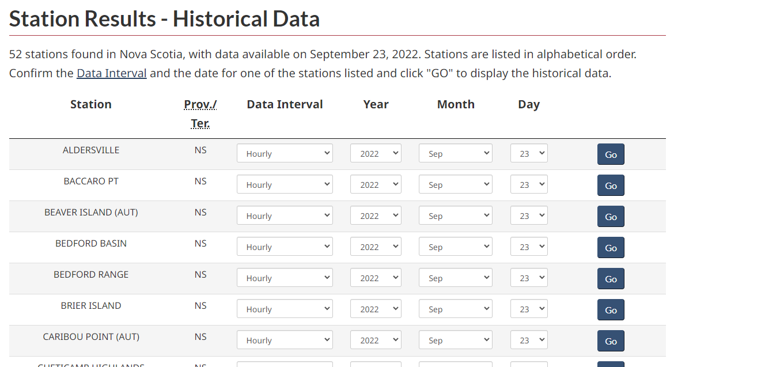

# Wednesday 22/10/19

Today we will generate a map of Nova Scotia with the positions of the weather stations and adjustable-radius circles around each position.

We will also begin to figure out how to make calls on the [MSC Geo-Met Surface Weather Observations](https://api.weather.gc.ca/collections/swob-realtime) APIs, hoping to have that nailed down by next Tuesday.

Here is a [link](https://guides.library.duke.edu/QGIS/ImportData) to uploading a CSV file to QGIS.

Do this for each CSV file.

I then follow the instructions to upload a CSV file and open the CSV file in QGIS to look at the Longitude and Latitude.

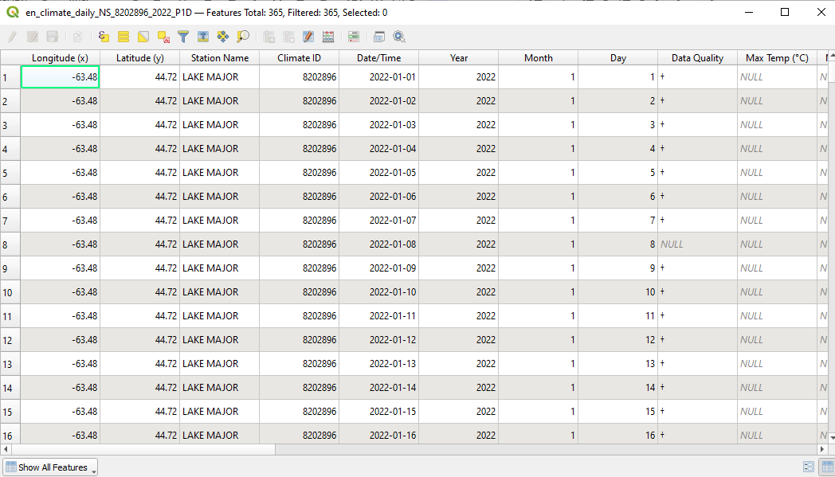

I picked the go option in the search box.

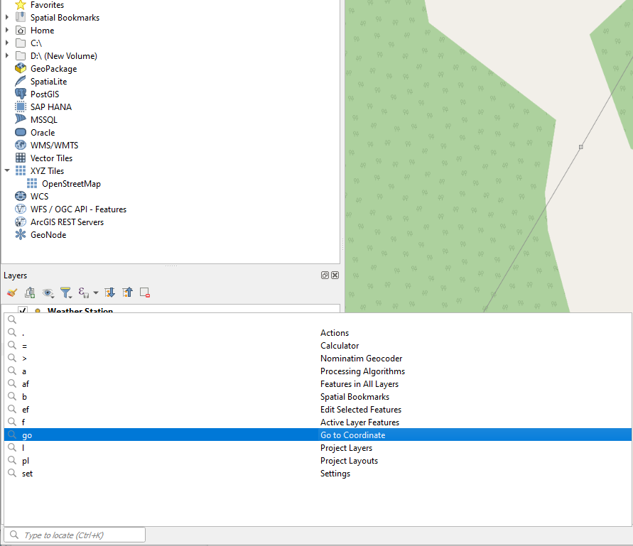

I put the Longitude and Latitude in the search box.

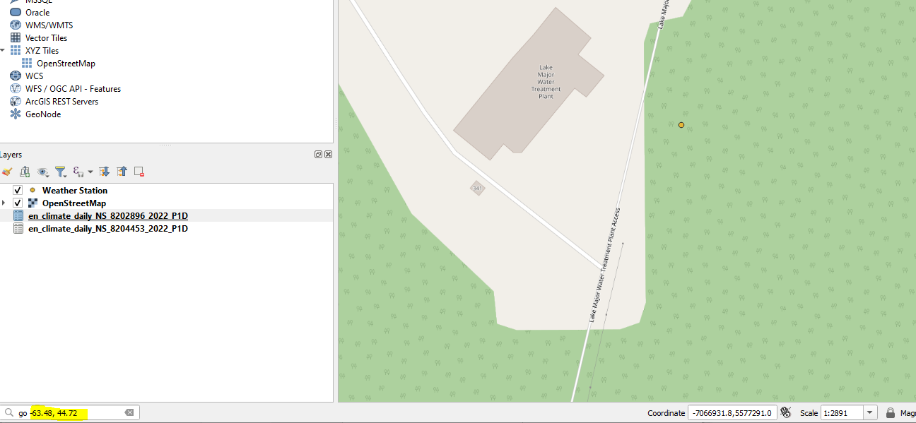

I then create a new shapefile.

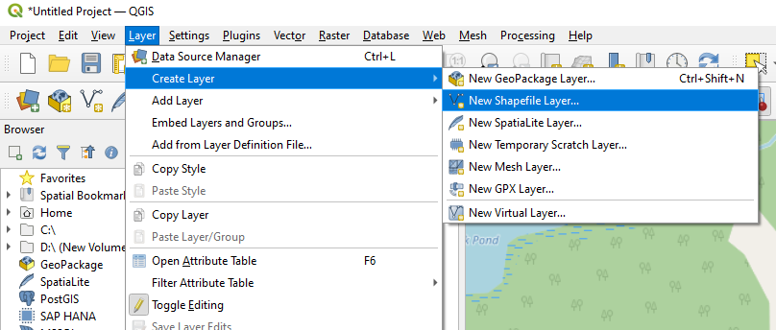

Once the shapefile is made, I then add a point which represents a weather station.

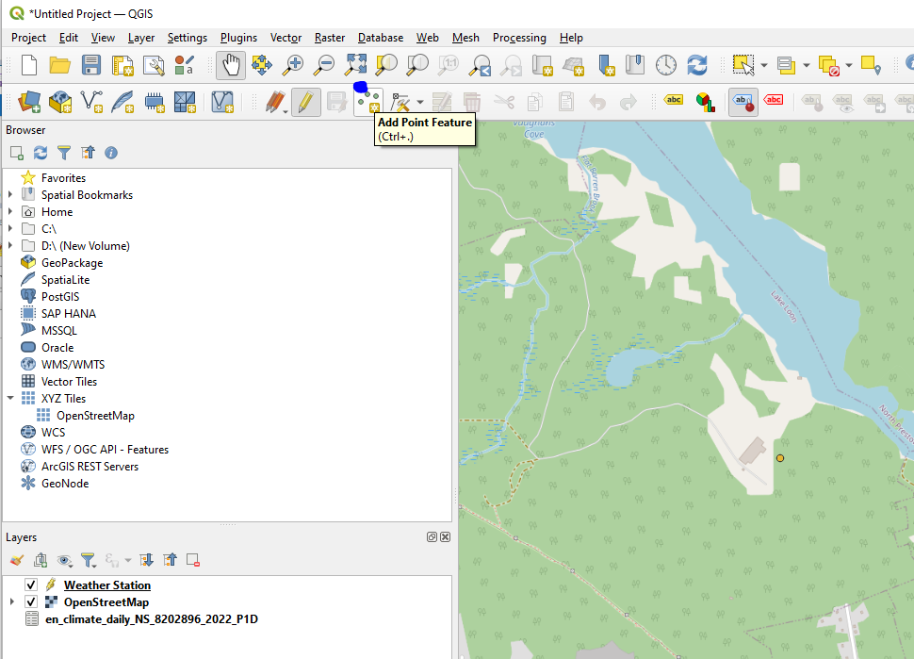

I then open the shapefile’s attribute table and click the pencil icon to turn on editing.

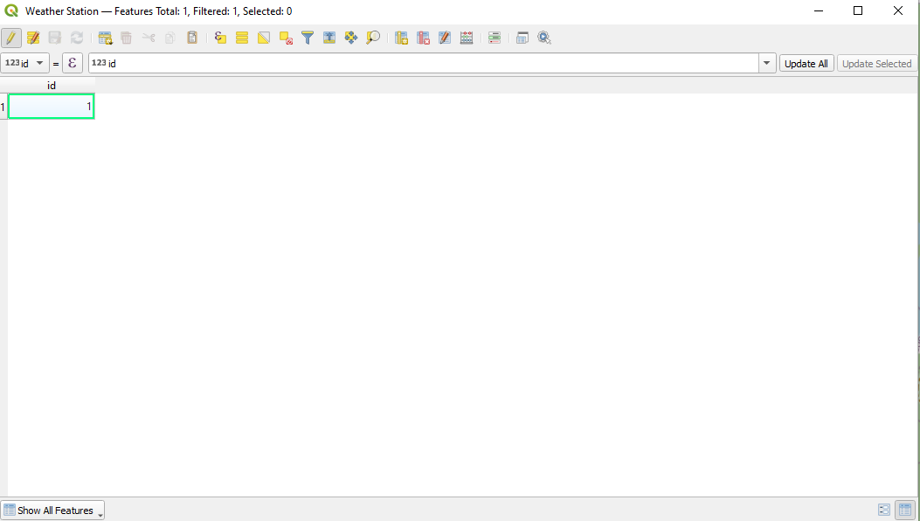

I then create a new field to put the Station Name in to distinguish the weather station.

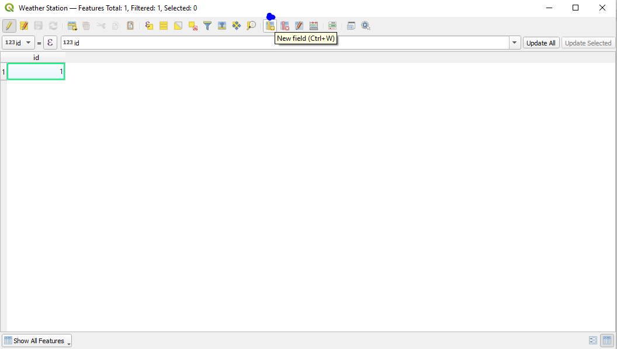

New field

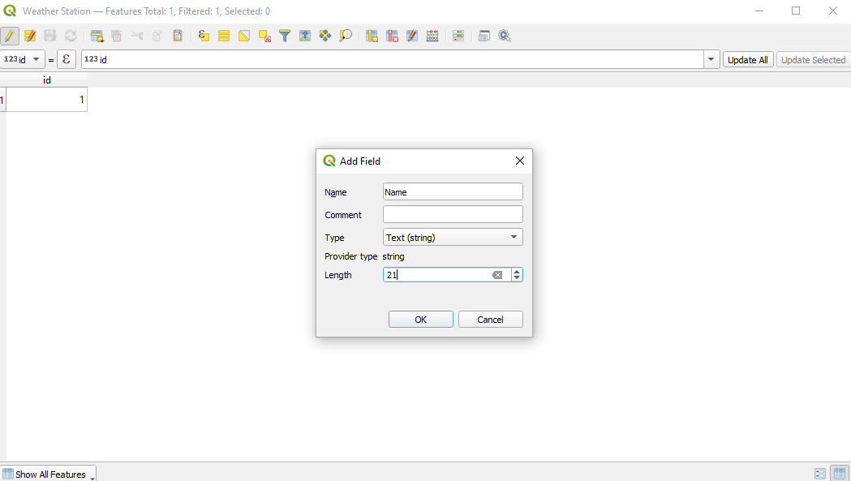

I then type the Station Name in the new Field “Name.”

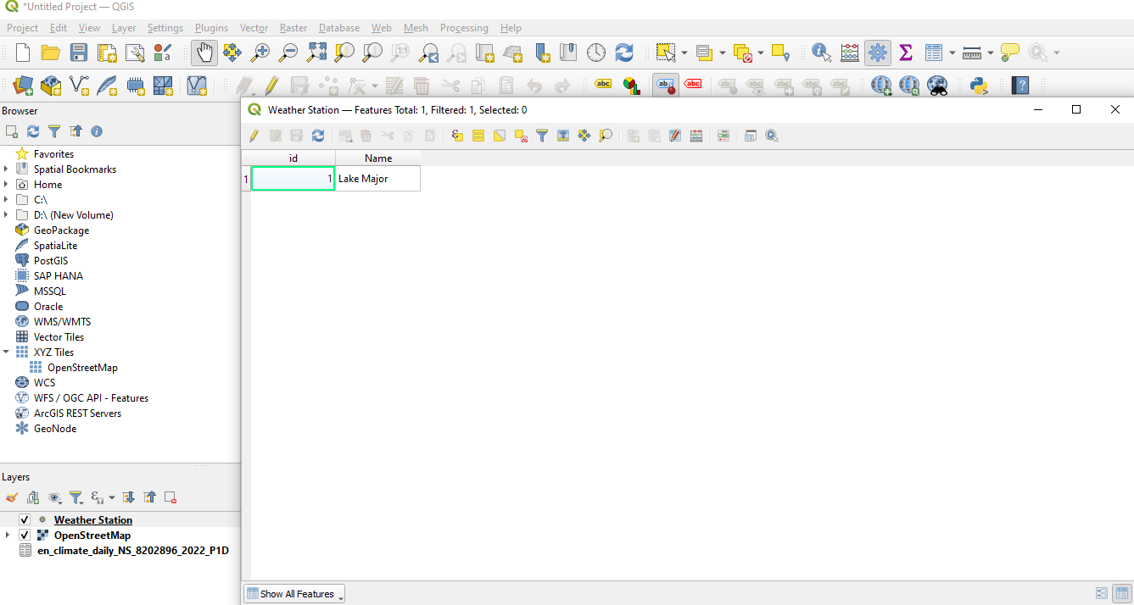

Repeat this for the next CSV.

# Monday 22/10/24

Today we will upload the the MCS hourly data, by weather station, for 22/09/23-24 that has a computed estimate of period-cumulative wind energy (the sum of hourly wind speed cubed). The objective is to have circular “regions of influence” around each station that are color coded for the magnitude of the estimated cumulative wind energy. We may then try to overlay these with various damage maps e.g. power outage, flooding, etc.

I got the CSV file with all the weather stations and imported it into QGIS the way Jeff McKenna showed me.

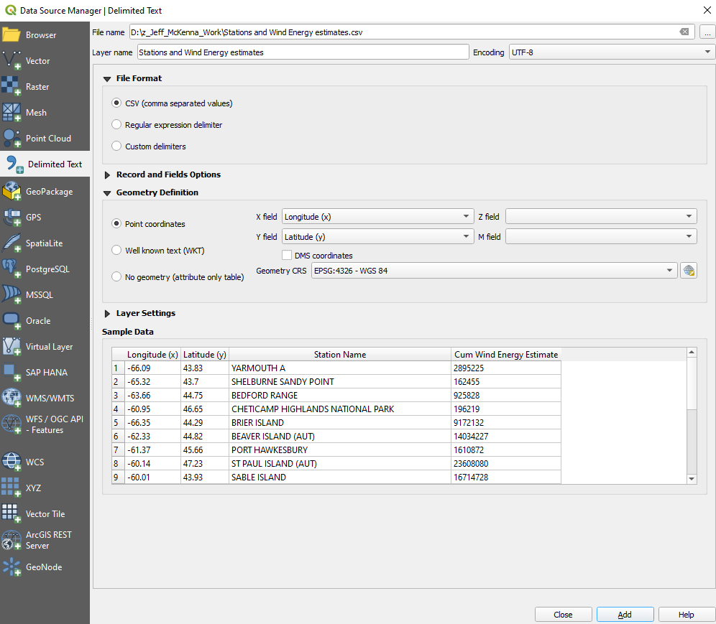

Symbolized the Cum Wind Energy Estimate.

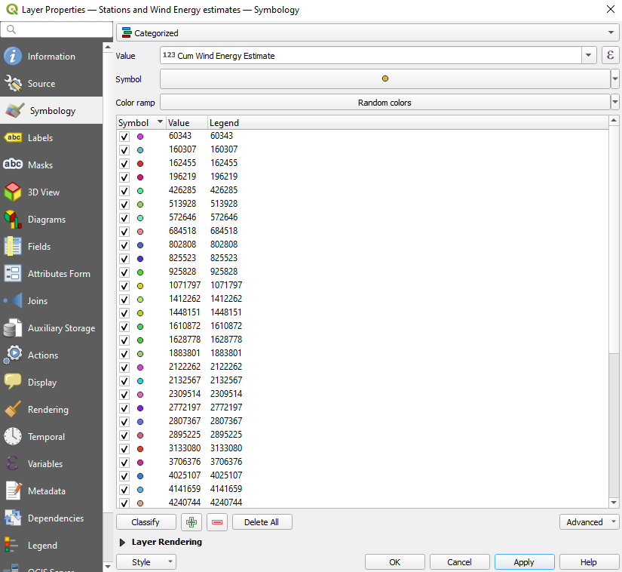

# Tuesday 22/10/25

Today we will try different circle sizes for the weather station locations to find what seems to be the best coverage. We will add a base map layer for Nova Scotia, try different color spectrum gradations for cumulative energy, and search for Fiona disaster data we can overlay on our map. Possible search terms: “Fiona disaster maps Nova Scotia” and “Fiona power outage maps.”

I tried a circle size of 2.00000.

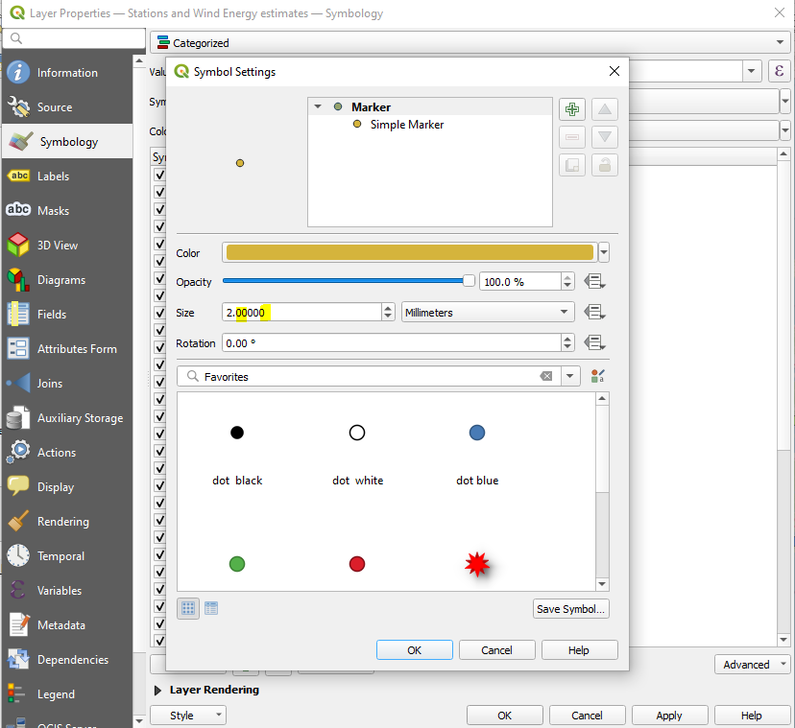

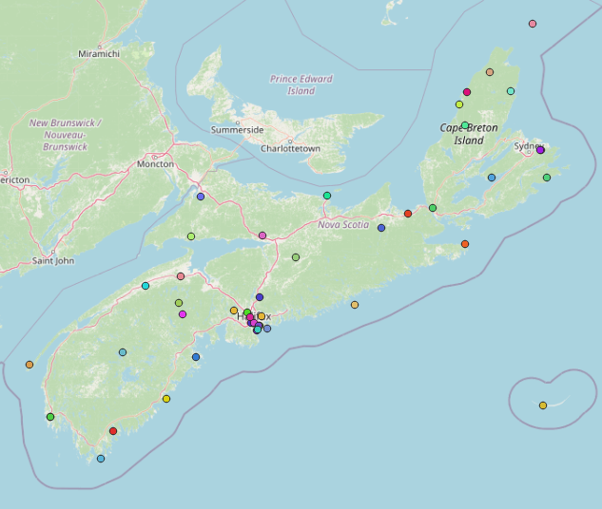

Now I changed the symbology to a color gradations of green.

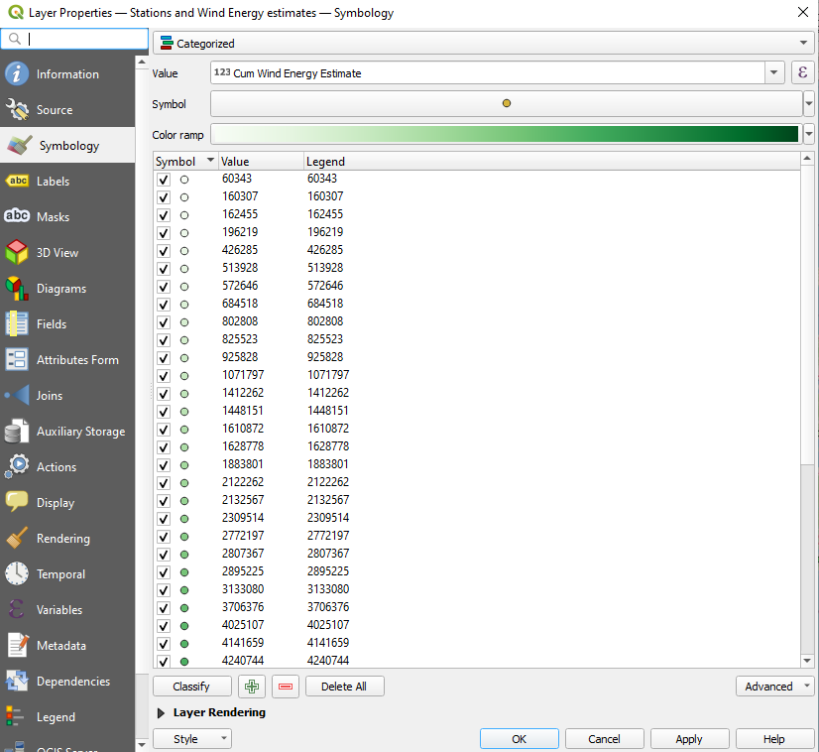

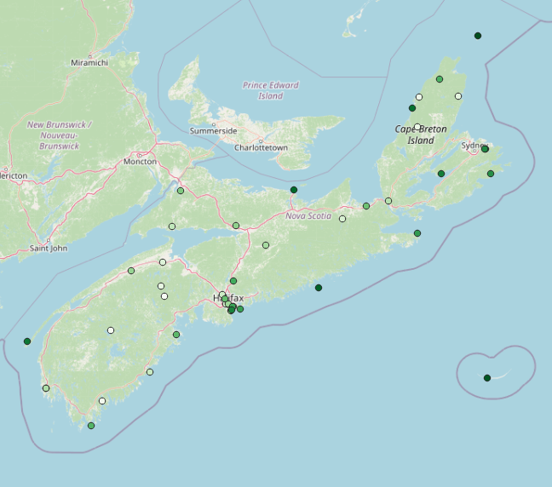

I searched for Fiona data and couldn’t find anything.

# Wednesday 22/10/26

We will mostly shift to preparing for tomorrow’s meeting with Jeff. Tomorrow we need to clearly explain what we are investigating (“areas with more wind energy had more damage”) and how we have tried to do it. We started with collecting MCS hourly Nova Scotia weather station data for 48 hrs of Fiona (22/09/23-22/09/24). Then we cubed each hour of wind speeds (energy in a flow is proportional to the cube of velocity)

\and summed them for each station as an estimate of relative cumulative wind energy. We plotted the weather station locations and added an Attribute for estimated relative cumulative wind energy. We have experimented with different marker sizes and color coding schemes. We may have more work to consolidate data from over-represented regions like Halifax.

We now turn to Jeff for help with accessing a [GitHub repository](https://github.com/danp/nspoweroutages) of historical Nova Scotia power outage data so we can overlay these with our wind energy estimates.

Or maybe Jeff has better project options and can direct us in some detail.

Presentation Agenda:

1. Introduction to the Project
   1. What we wanted to investigate (wind damage by Hurricane Fiona in Nova Scotia)
   2. Our analytic approach: we think wind energy is related to damage like power outages and we can estimate weather station cumulative wind energy as the sum of the cube of hourly wind speeds over the Fiona window, so we looked for historical hourly Nova Scotia wind speed data.
2. How we tried to get the data (researched weather data sources and found natural resources Canada)
3. How we got the data (downloaded weather station data from NRCAN’s historical data for Nova Scotia and made a csv file of all the stations’ wind speed data for Sept. 23 & 24)
4. How we plotted the data (added a new column with wind speed data cubed and in QGIS, added the csv)
5. Other data we need but can’t figure out how to access (found NS Power outage data repository on GitHub but we can’t figure out how to download it)
6. Other ideas for projects related to the work we will do for Gateway and a request for more detailed direction

I am trying to find a way to download the Github power outage data and find no way. All the data is json which is not WMS.

So I searched for ways to download from Github. Right click the json file and click save link as and you will find the json file where you downloaded it.

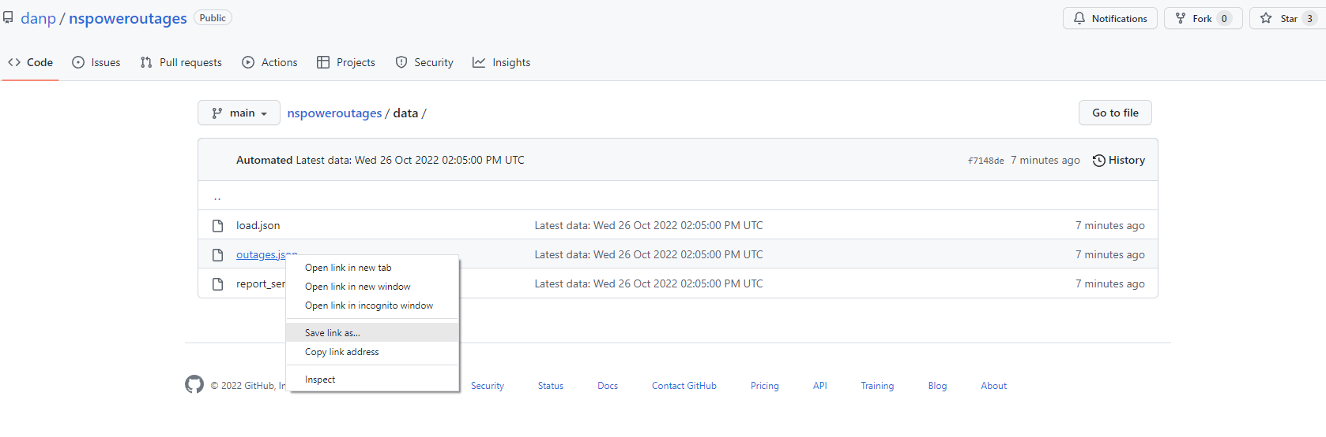

I also found a way to [upload](http://wiki.bk.tudelft.nl/toi-pedia/Importing_GeoJSON_files_to_QGIS#:~:text=Step%202%3A%20To%20import%20your,created%20with%20the%20GeoJSON%20geometries.) json files to QGIS.

Unfortunately, it didn’t work on one file.

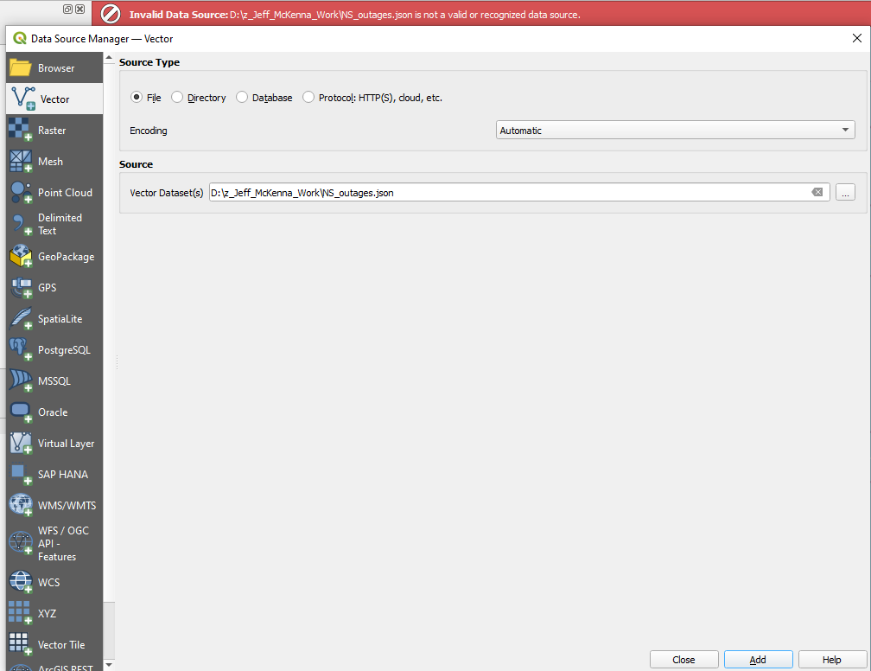

So I clicked on Plugins which you can easily install plugins.

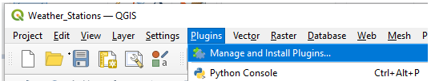

I searched for json and installed the JSON Eater.

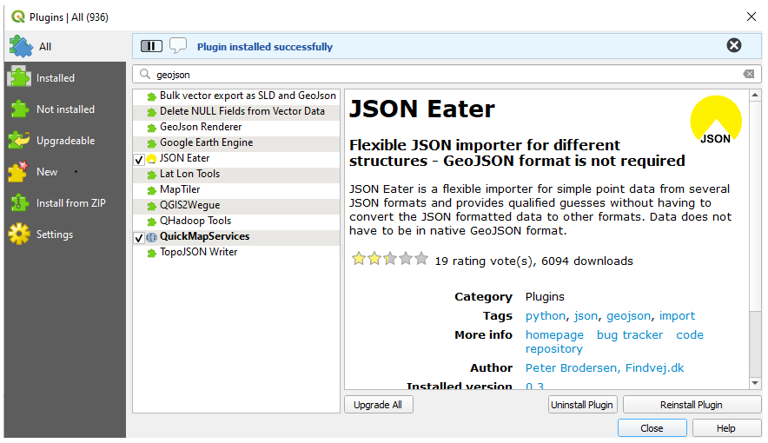

I then Tried the JSON Eater.

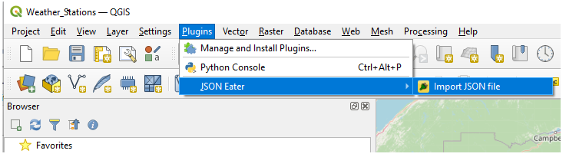

I clicked on Eat JSON and nothing happened.

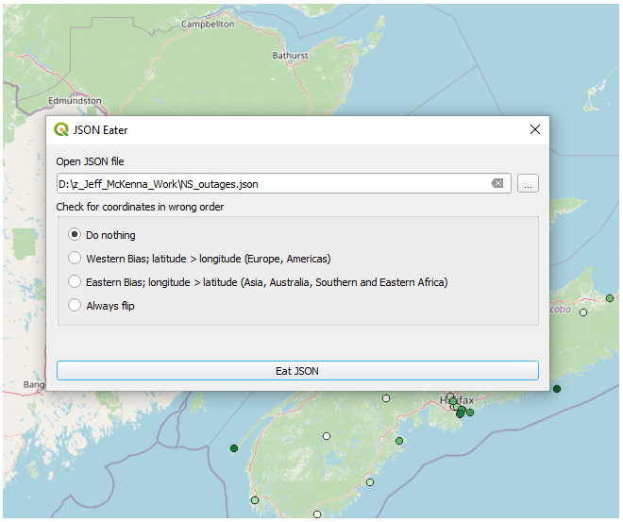

# Monday 22/10/31

Today we will continue to try to find how to access the right NSP outage data (lagged 8 hours compared with the Fiona wind energy window) from the GitHub repository. Google, wise friends, the owner of the repository, whatever we can think of …

I tried to look for ways to download from GitHub and found nothing so far. I found out you need geojson and I found an [online tool](https://products.aspose.app/gis/en/conversion/json-to-geojson) to convert json to geojson. It didn’t work for me either.

I went to [Outage Summaries](https://nsp.datasette.danp.net/outages/outage_summaries) and went to the very bottom of the page of the link and downloaded the CSV and put it in QGIS.

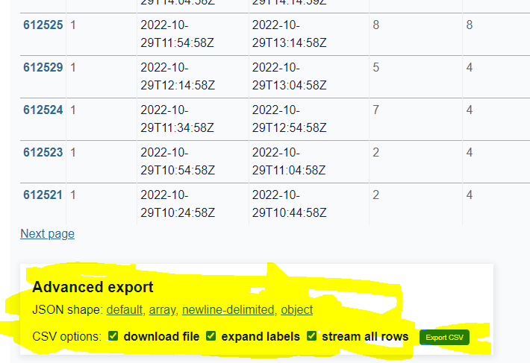

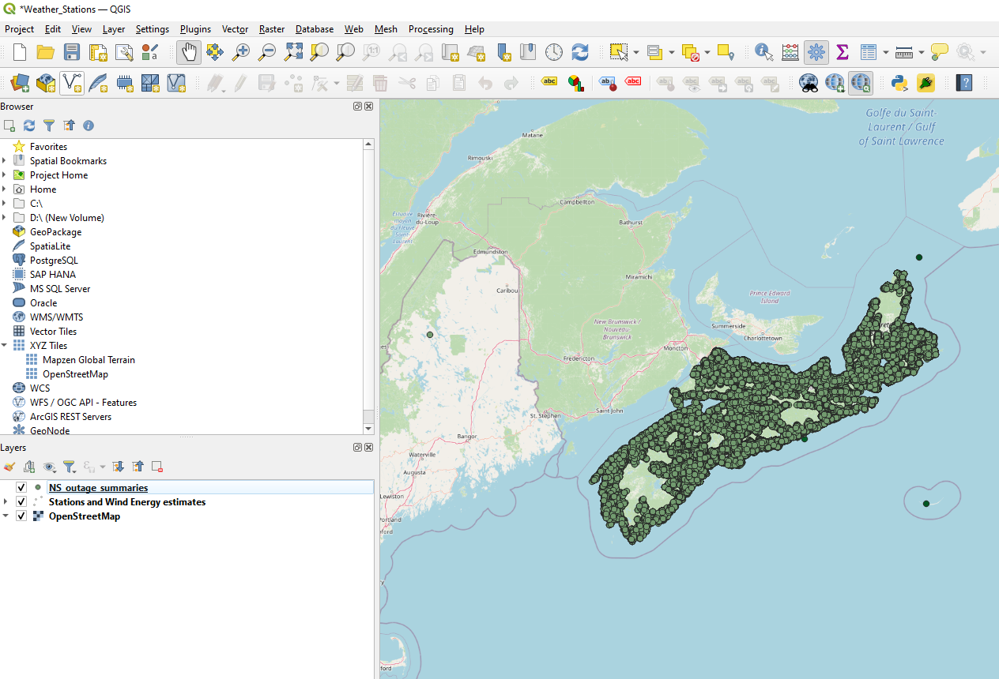

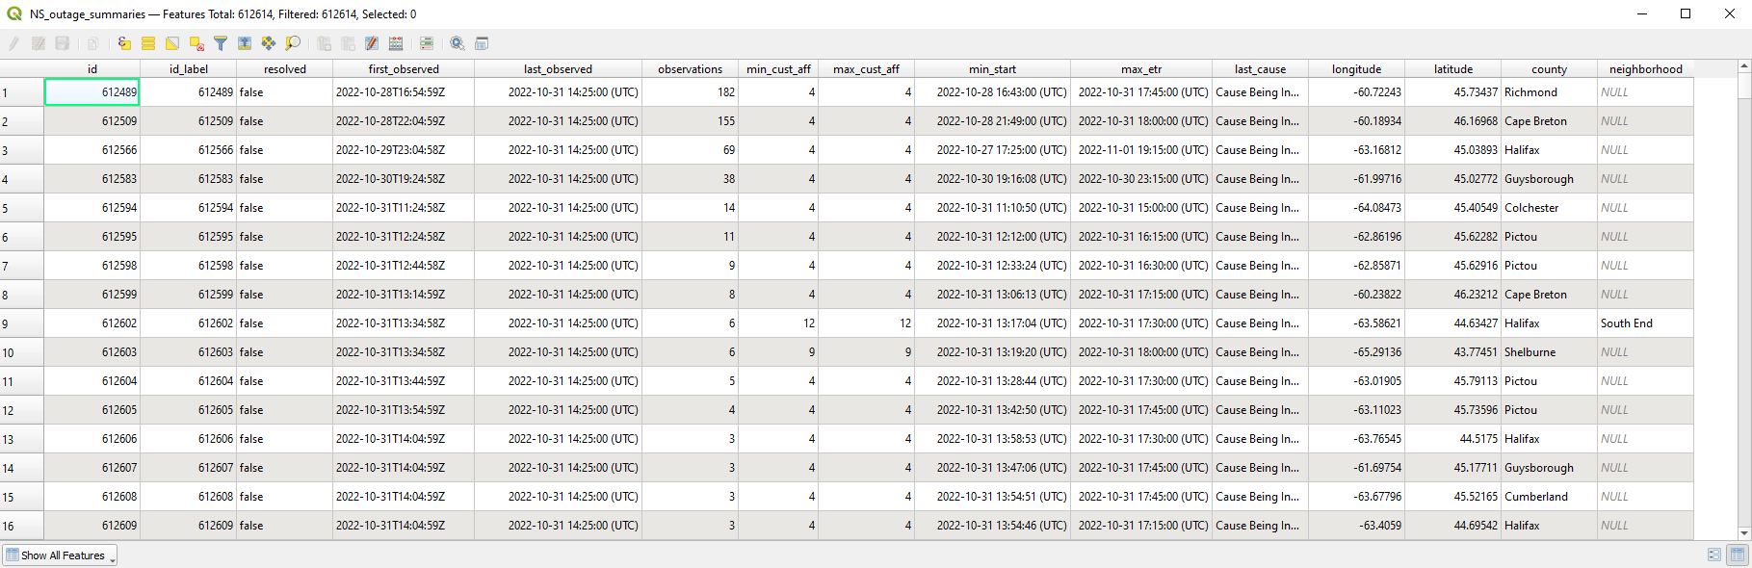

# Tuesday 22/11/01

What project should I do? Should I keep working on the current project? Taking over the Google doc - initiating what needs to be done is overloading.

I wrote Jeff McKenna those questions.

# Wednesday 22/11/02

Things we can do until we figure out what to do:

1. I want to access Excel to get the outage data for the Fiona window.

I got another way which is fine in notepad++.

I went into the outage summaries and removed everything outside the Fiona window and saved it as a new csv so the original csv exists in case we need to go back to it.

I also symbolized the power outage by cause.

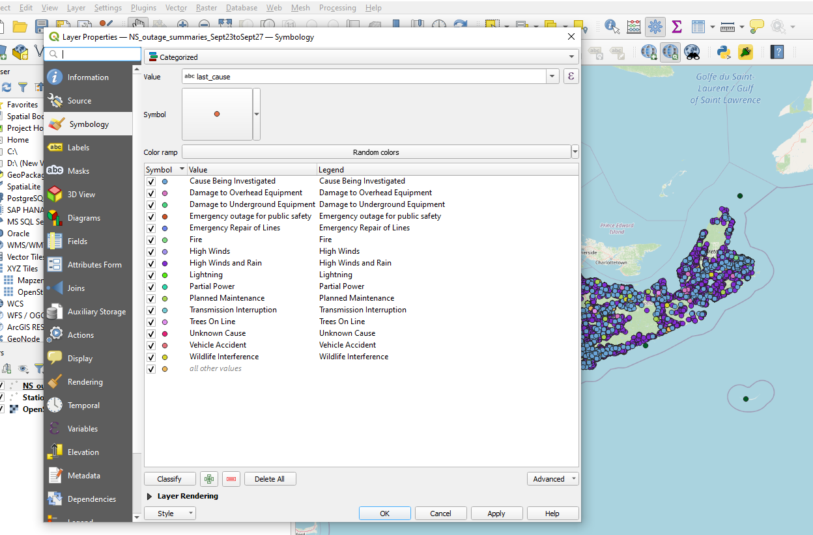

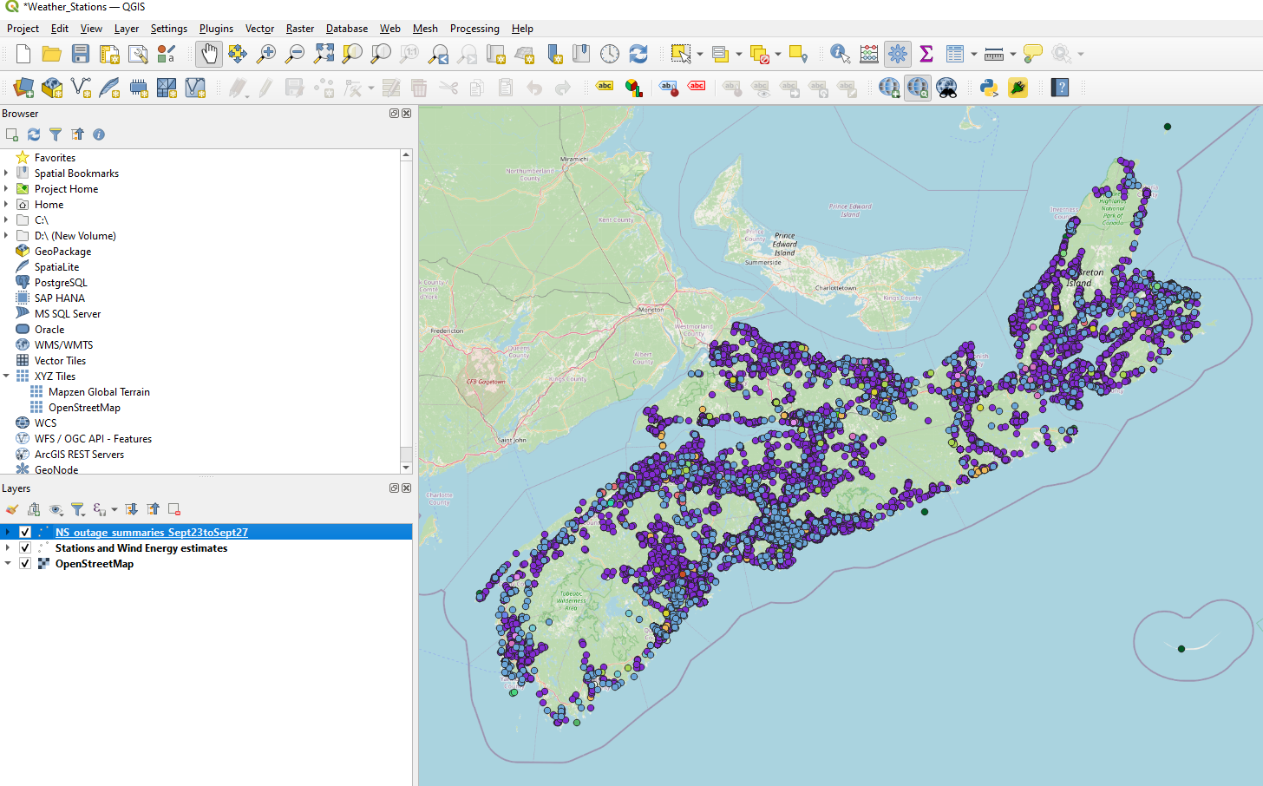

I downloaded the power outage summary csv table with the query for 24 & 25 Sept. 2022 using this [link.](https://nsp.datasette.danp.net/outages/outage_summaries)

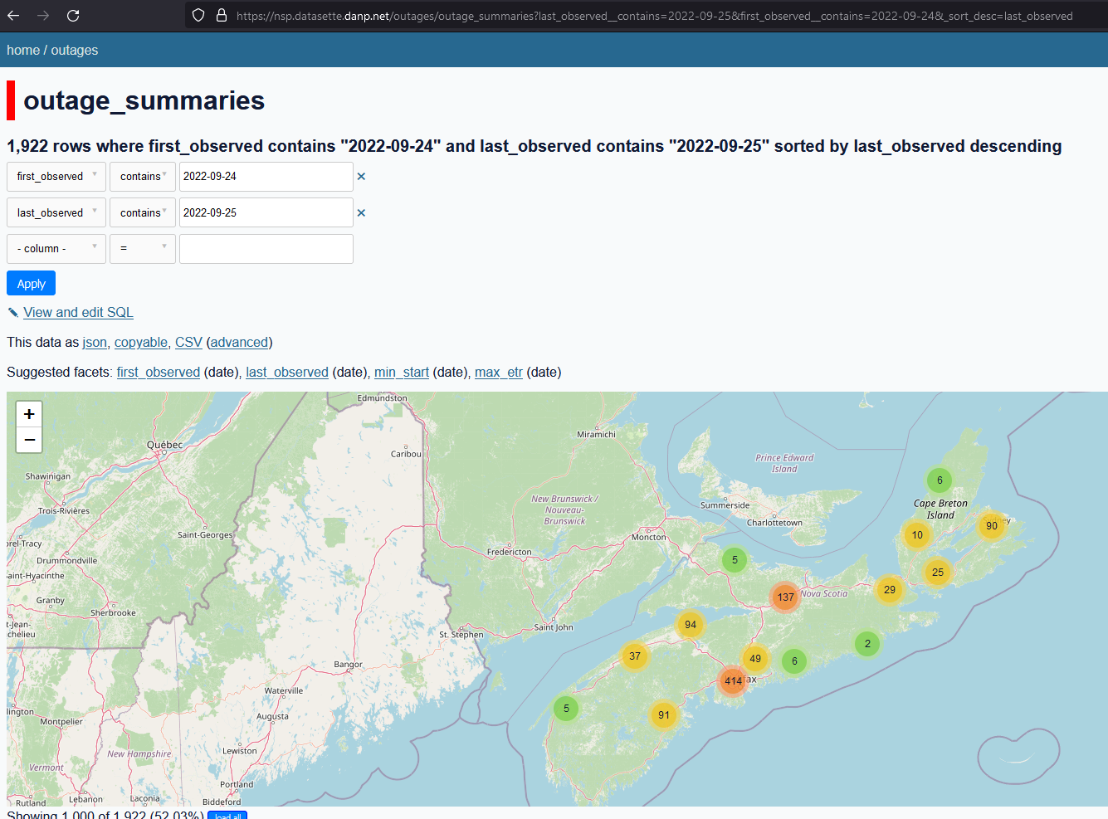

Here is the attribute table.

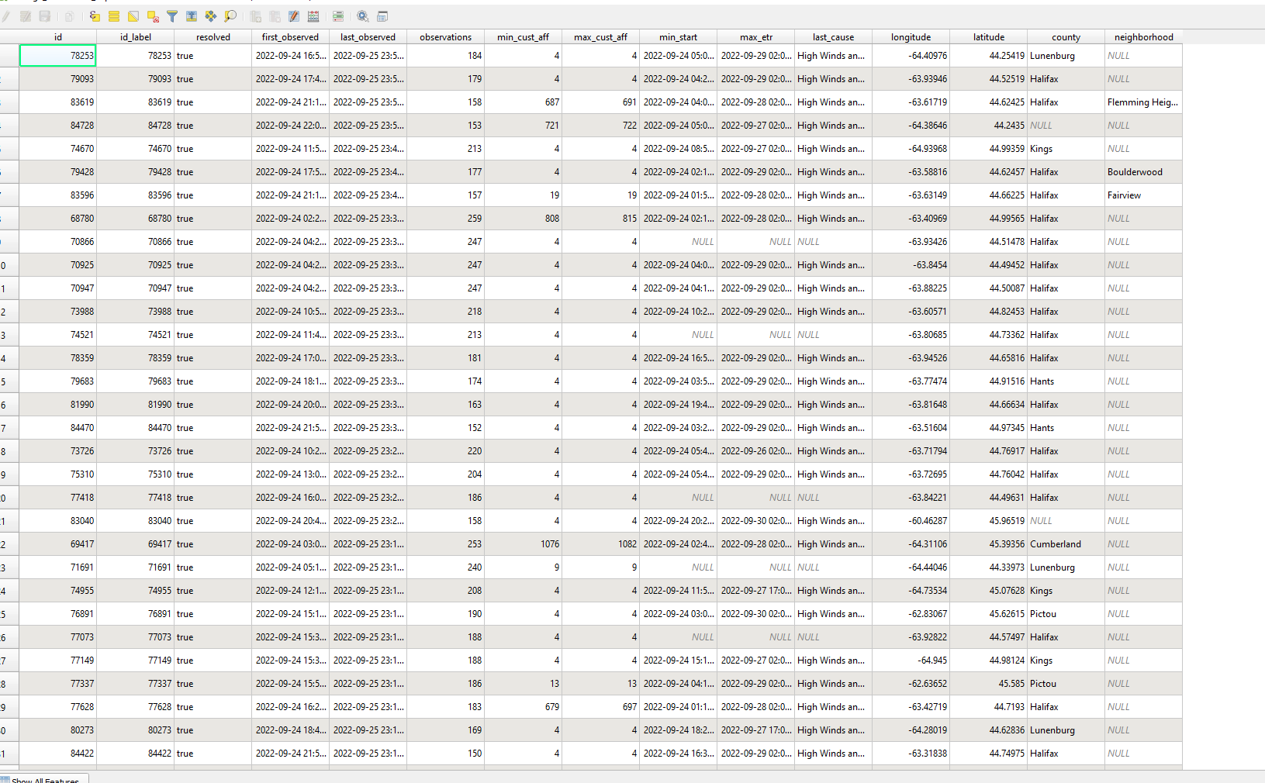

Here is my map with the power outage data for Sept. 24 & 25, 2022.

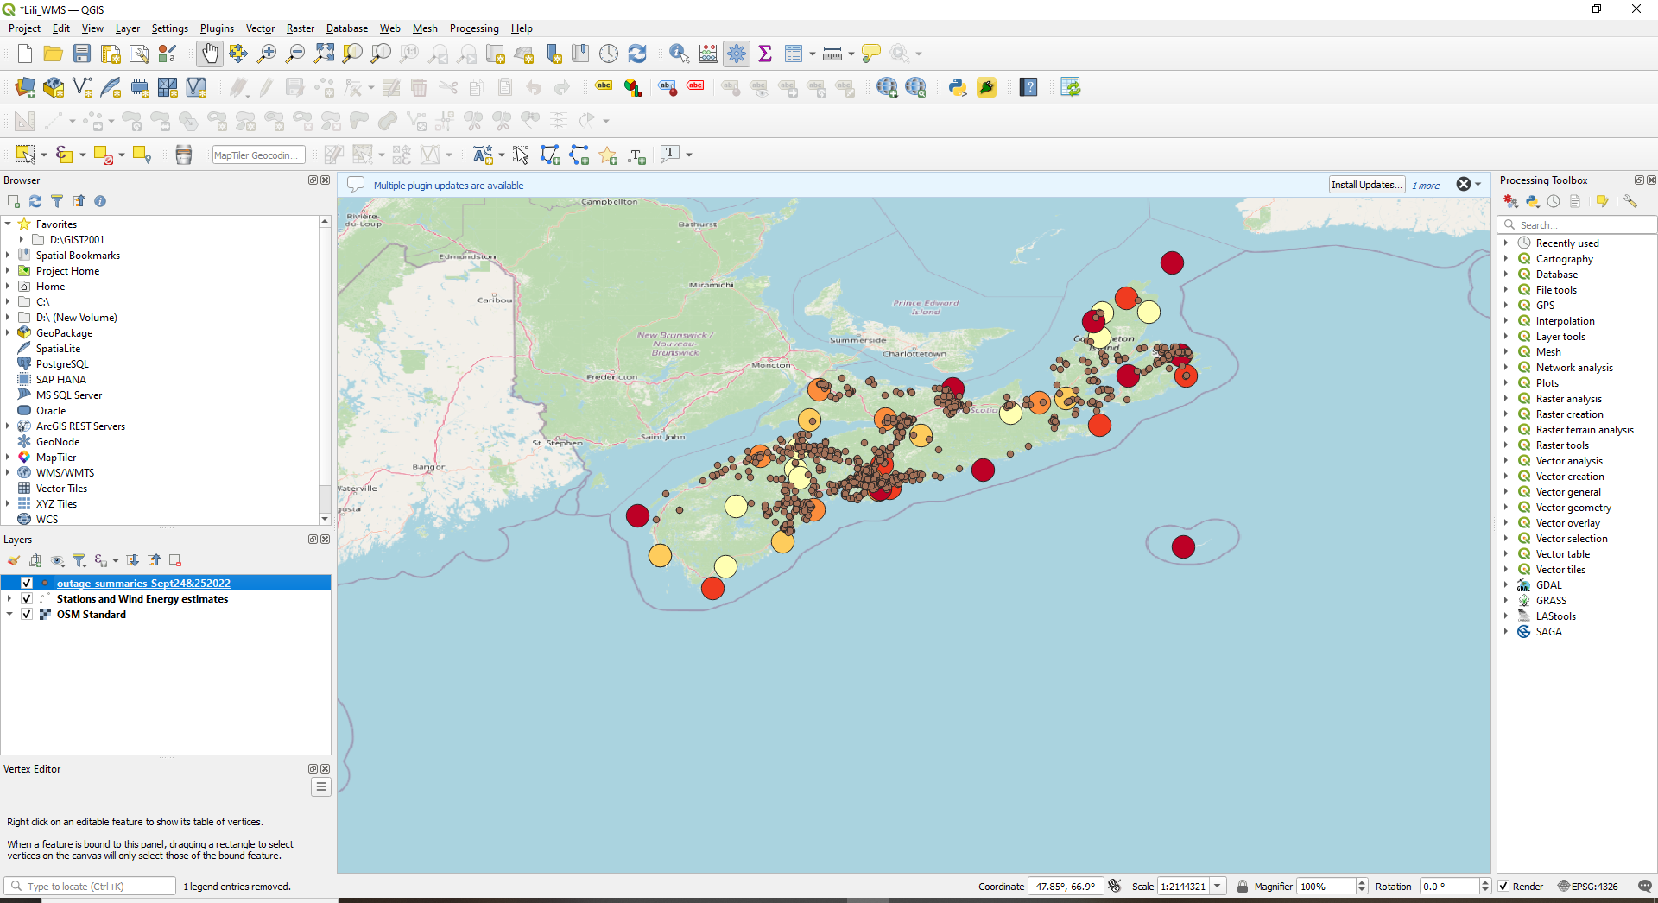

# Monday 22/11/07

1. How to only use the 8hr-lag data on power outage data. Power outages occur after Fiona passes through.I wrote Jeff Mckennas on
2. What should we do next? Take a course on GitHub use?
3. Take more QGIS courses? Esri courses?
4. Tell us more about what to expect for the meeting next week.
5. What kinds of work would Gateway have me do?

I turned the symbology a little bit. The orange is caused by the storm, the green is not caused by the storm, and the purple ones are maybe caused by the storm or maybe not.

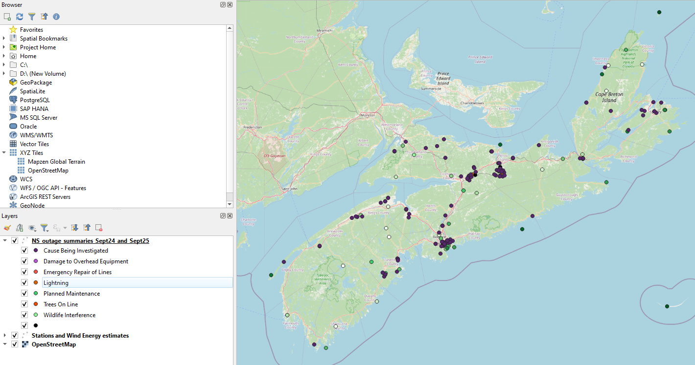

I still couldn’t find a good spot for 8 am on Sept 25th. The highlighted shows that the time of day is not in order.

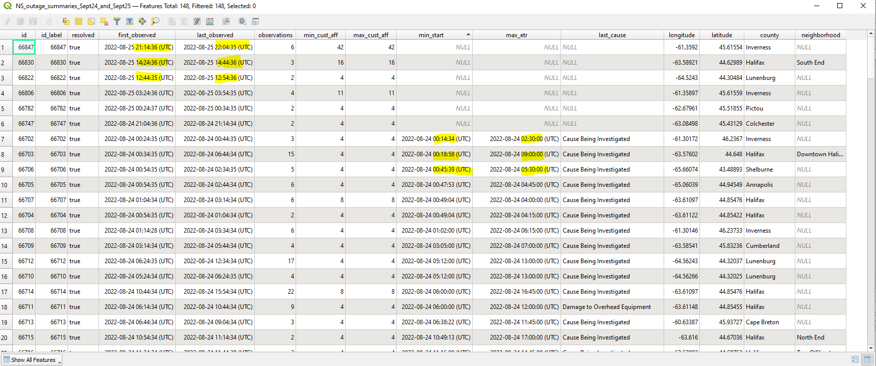

# Tuesday 22/11/08

How to only use the 8hr-lag data on power outage data. Power outages occur after Fiona passes through. I wrote Jeff Mckennas on

Haven’t heard back from Jeff McKenna. I that I need help on finding the 8-hour lag as the times of day are not clearly shown. I changed the symbol of the wind energy estimates as arrows over the power outage data. The red color has the most cum wind energy estimate and the blue is the slowest. The orange, green, and yellow are in between.

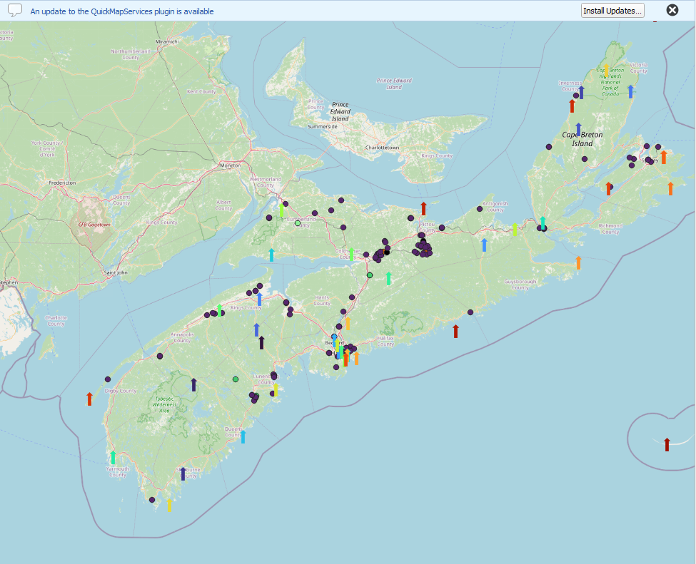

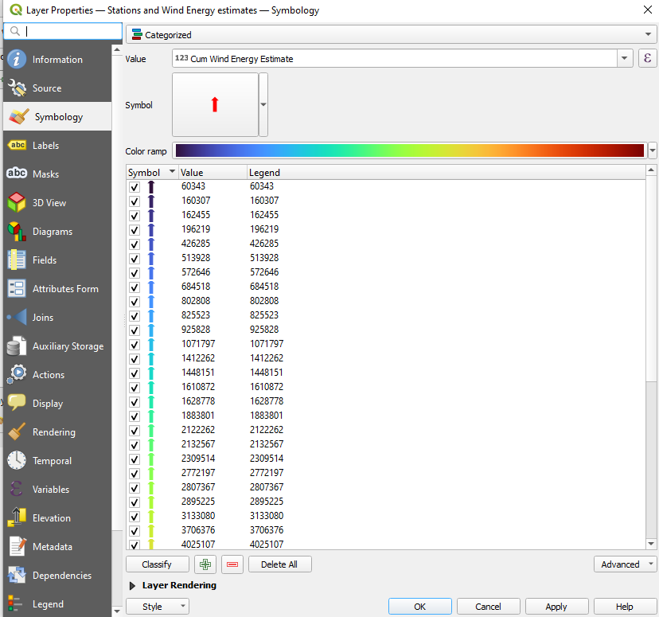

# Wednesday 22/11/09

Asks Jeff McKenna whether to wait or not till Thursday to learn about GitHub.

I did the GitHub [tutorial](https://docs.github.com/en/get-started/quickstart/hello-world).

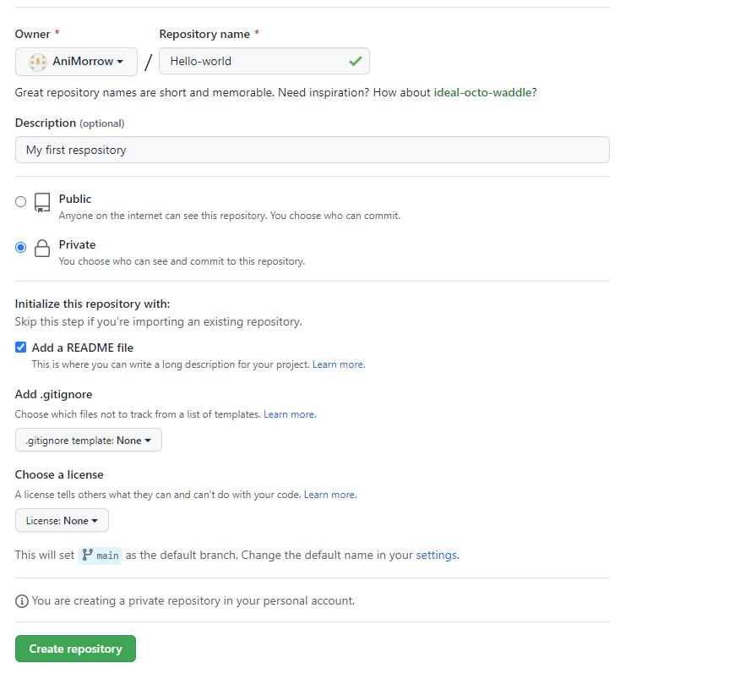

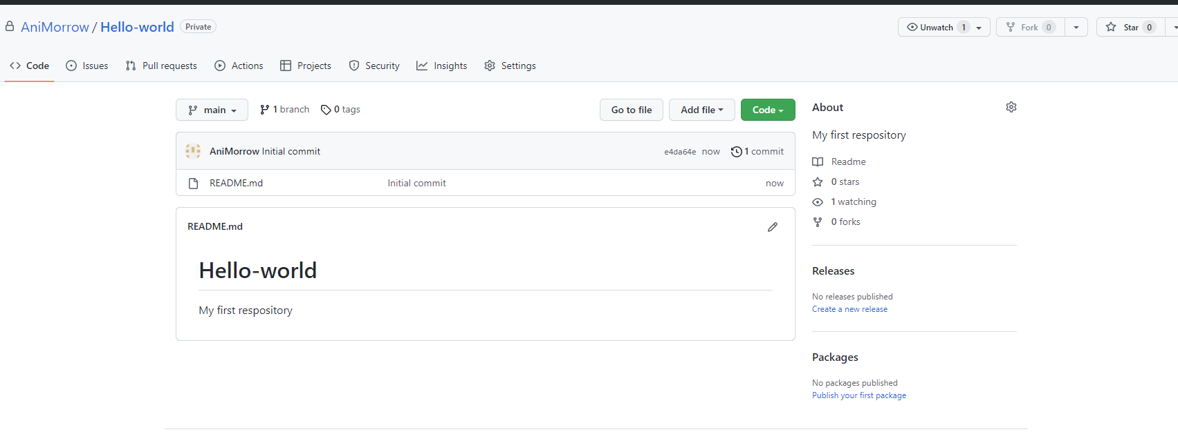

Created a branch

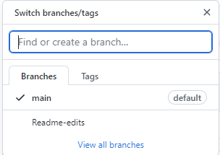

I tried to edit my Readme file and the commit changes button was disabled.

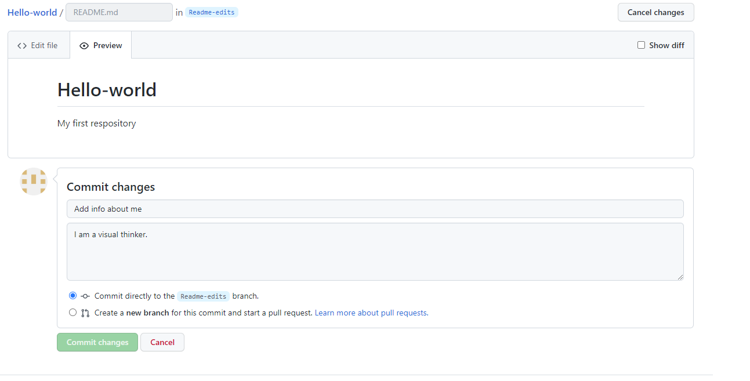

So I went to these help links [Stack Overflow](https://stackoverflow.com/questions/62375561/to-enable-commit-button-in-github#:~:text=The%20reason%20why%20the%20commit,might%20not%20have%20that%20access.) and it led me [here](https://docs.github.com/en/repositories/configuring-branches-and-merges-in-your-repository/defining-the-mergeability-of-pull-requests/about-protected-branches).

The next step in the GitHub tutorial is opening a request.

# Monday 22/11/14

Upload map QGIS file and data to GitHub and ask about a zoom with Jeff for Thursday. I changed the use case 1 to power outages from Fiona.

# Tuesday 22/11/15

I am going to ask Jeff for next steps for work now that I have created my use case 1 and uploaded files to gitHub.

This is how I uploaded it to GitHub. The highlighted spots are where to click in your own gitHub.

Step 1

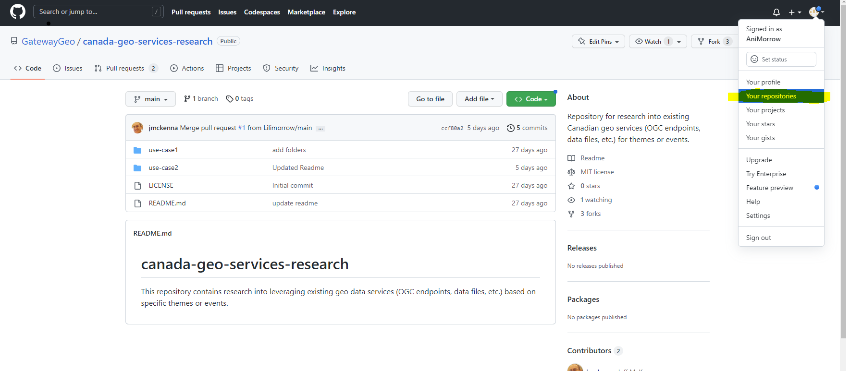

Step 2

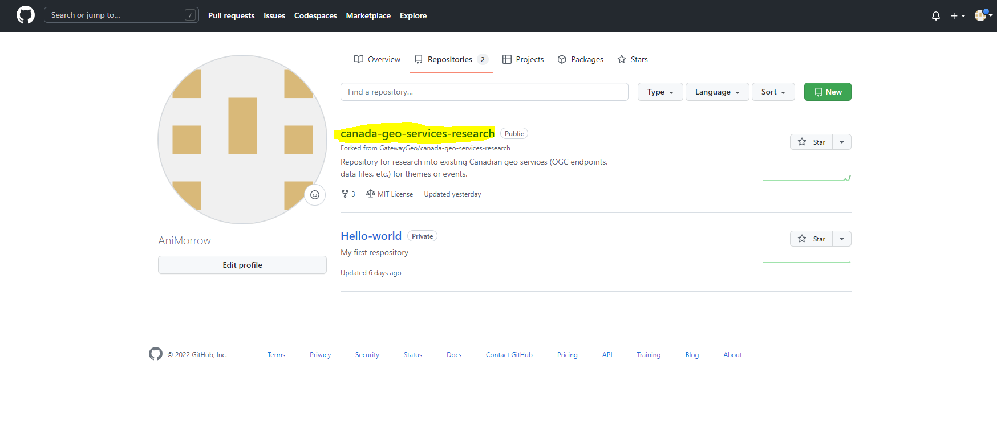

Step 3

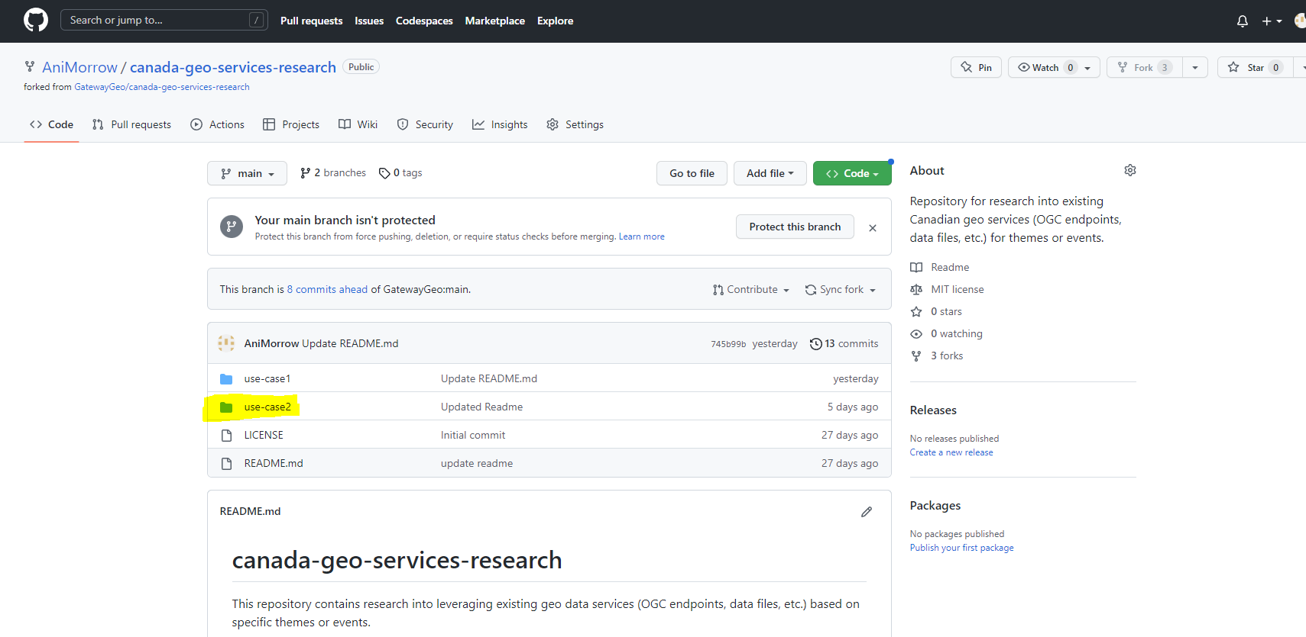

Step 4

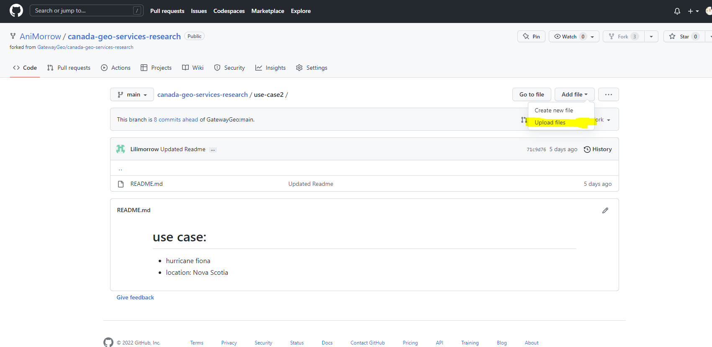

Step 5 drag your files into the box

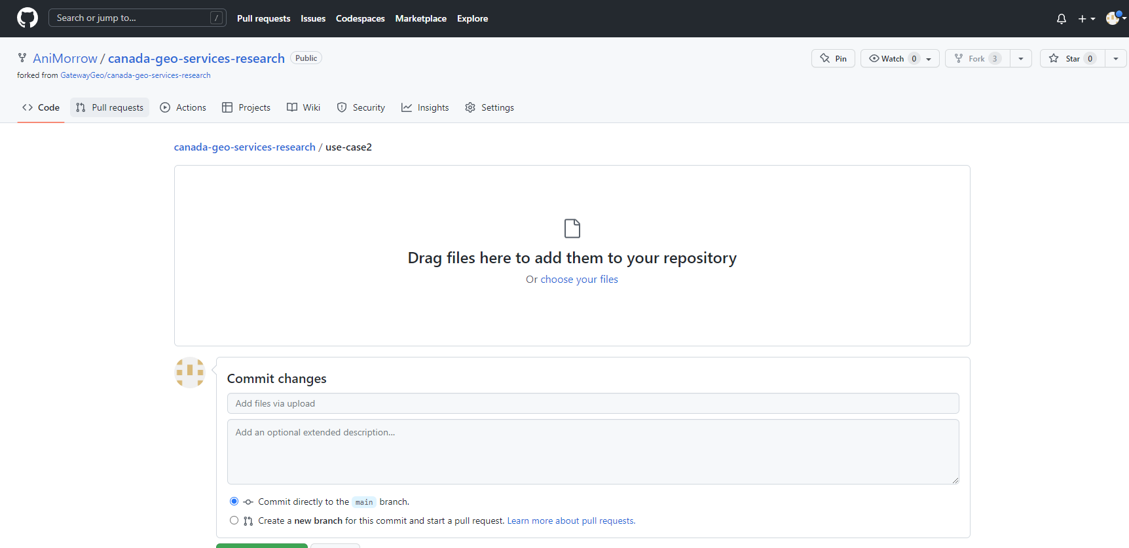

# Thursday 22/11/17

will add a use case for BC sea-level rise to her public repository. Will get help from my twin sister Lili to find data and refine the use case and possibly choose another use case if we can’t find the data. Other options include: forest fires, flooding, earthquakes, blizzard/snowstorm, pandemic, ...

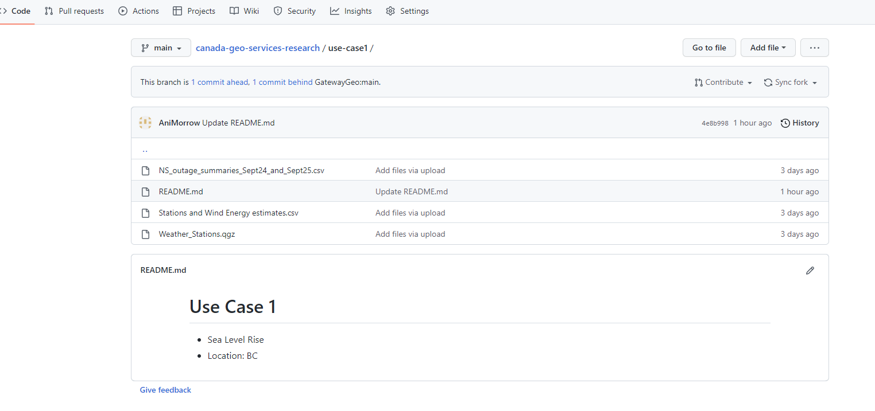

I was able to pull a request so Jeff McKenna would accept the change on his side of Github.

I saved it as a csv file. The file had no longitude and no latitude.

# Monday 22/11/21

[Link](https://cdd.publicsafety.gc.ca/srchpg-eng.aspx) to GeoSpatial data for Canadian disasters.

Here is a [link to my results](https://cdd.publicsafety.gc.ca/dtpg-eng.aspx?cultureCode=en-Ca&provinces=2&eventTypes=%27FL%27&normalizedCostYear=1&eventId=1127) which shows which fields are in the file. There is no lat and long still.

I downloaded the KML file. The highlighted parts are where to click.

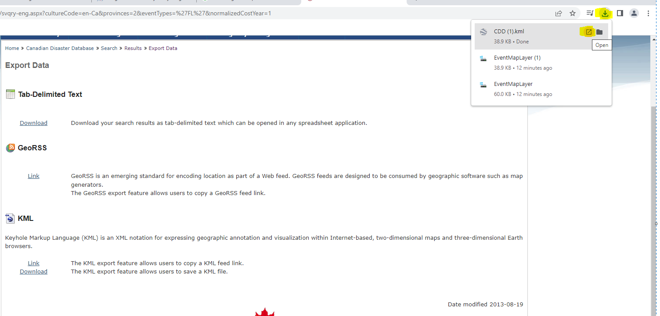

Here it is. It opens up in Google Earth Pro.

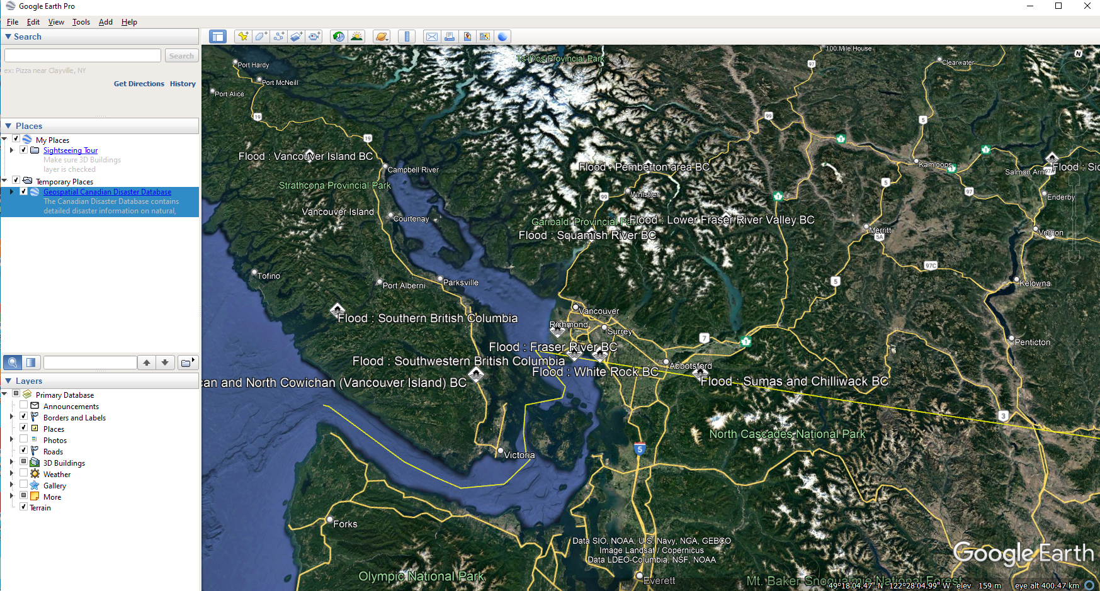

I tried [Lili’s link](https://www.spotzi.com/en/about/help-center/how-to-import-a-kml-into-qgis/) and I put it in QGIS.

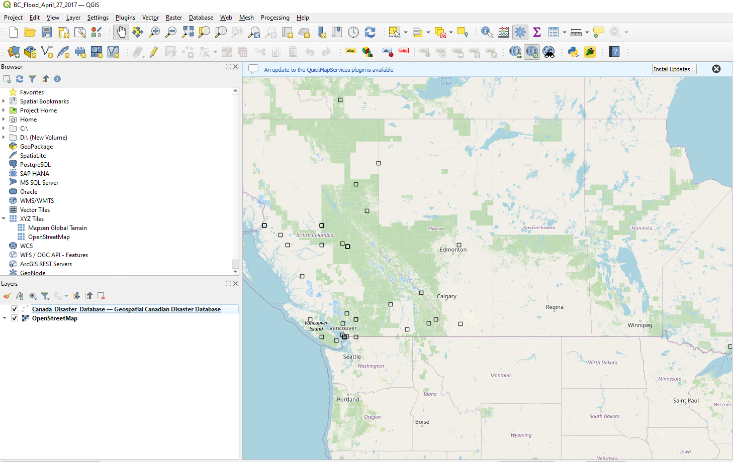

# Tuesday 22/11/22

Plot the disasters for one province by location and by cost (symbology) and add it to your repository.

My LML file has no cost attribute so, I symbolized it by location.

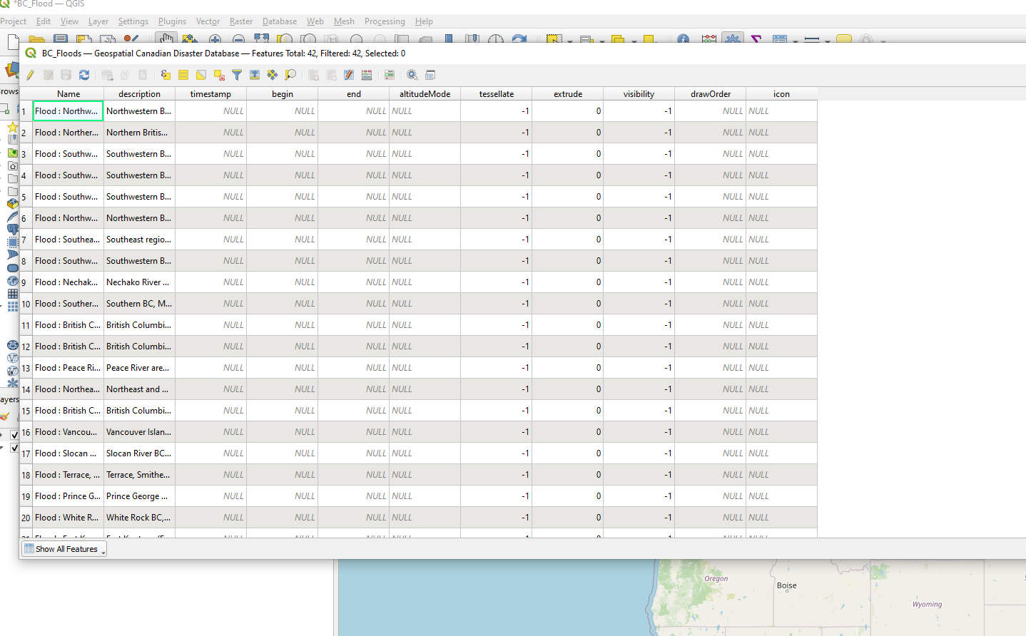

So, I symbolized it by location.

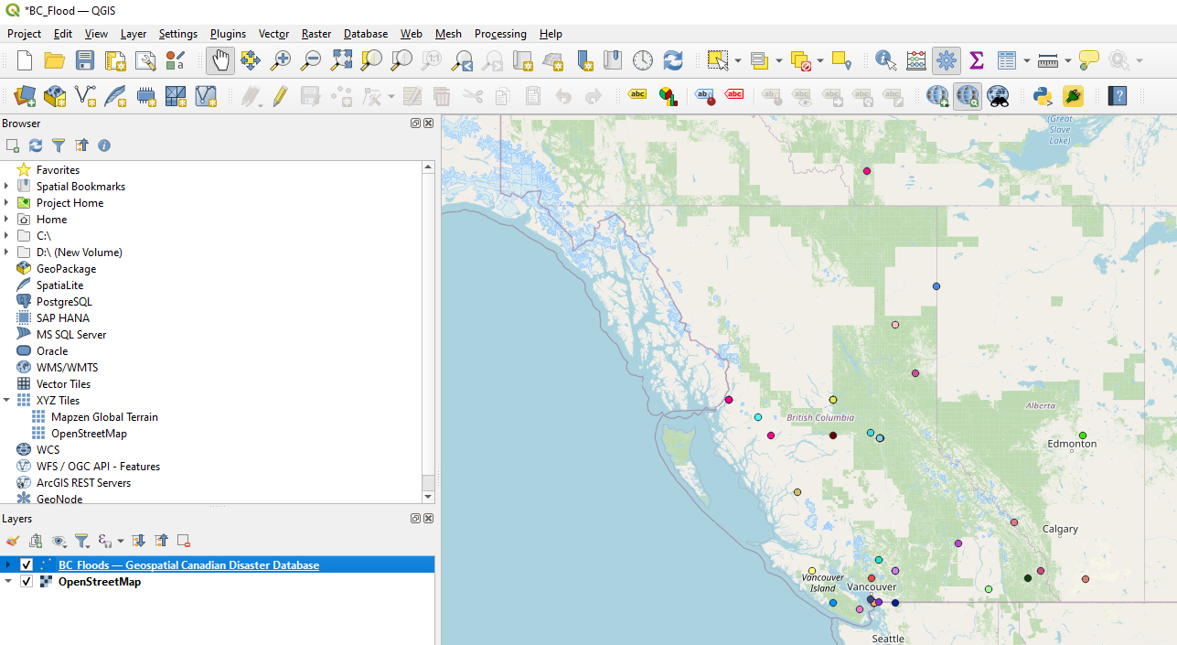

I uploaded files to my GitHub.

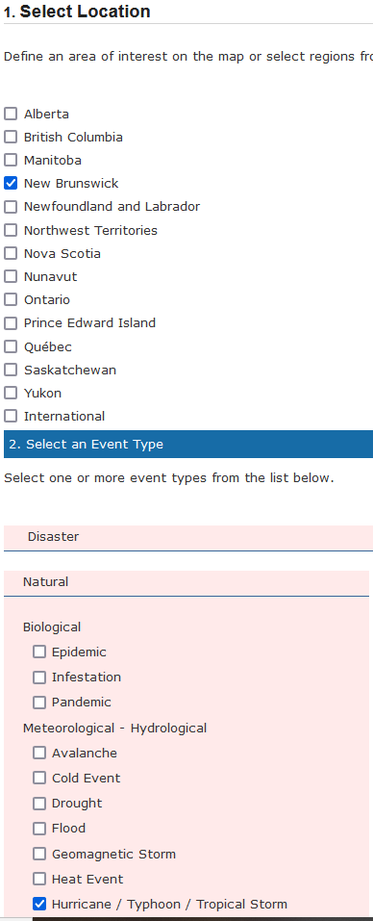

I displayed the new kml in QGIS.

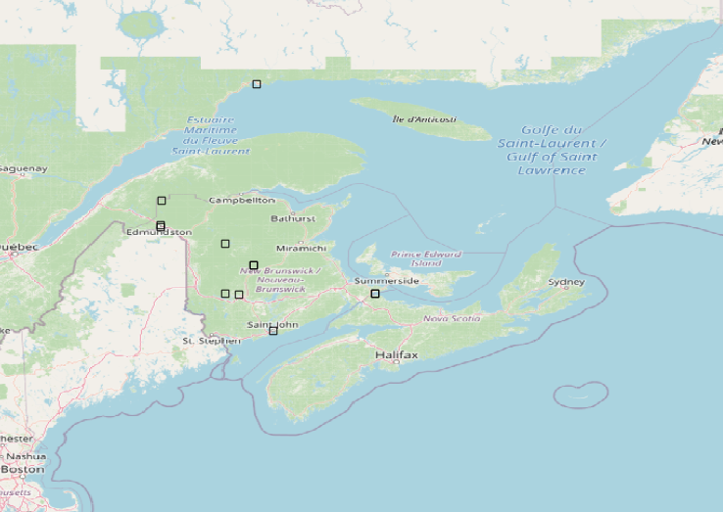

I can’t change the symbology however for the kml file. I converted the kml file to a shapefile using [this.](https://mygeodata.cloud/converter/kml-to-shp)

I then put the shapefile in QGIS and had the symbology by name as the other option in labels was “description”.

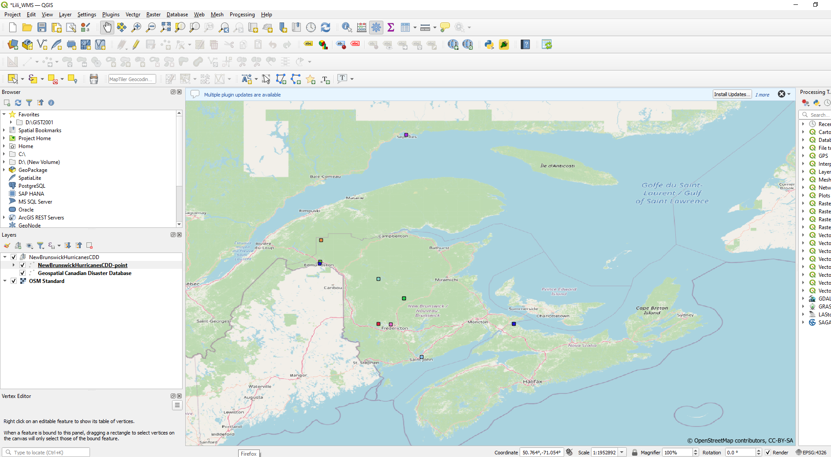

In the attribute table, I couldn’t find the values I wanted to use.

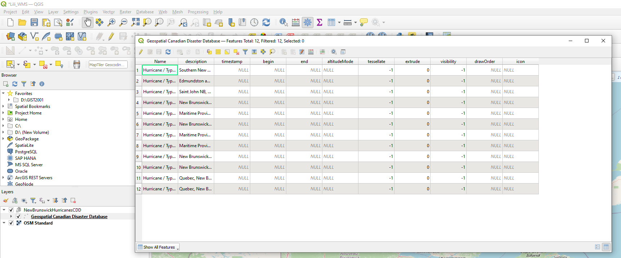

# Wednesday 22/11/23

Here are my results and I see Estimated Total Cost.

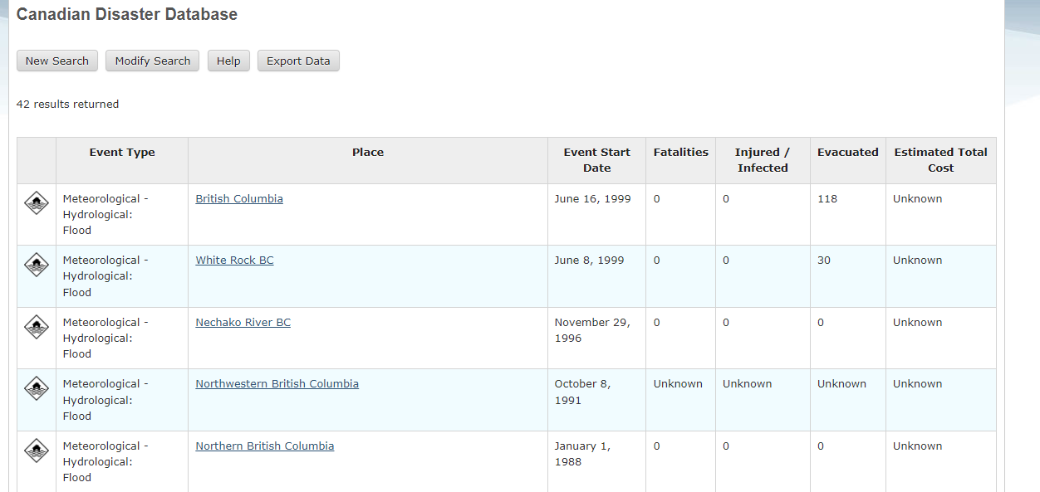

I went into QGIS and it somehow didn’t show the Estimated total Cost when I downloaded it again. Let’s figure out why.

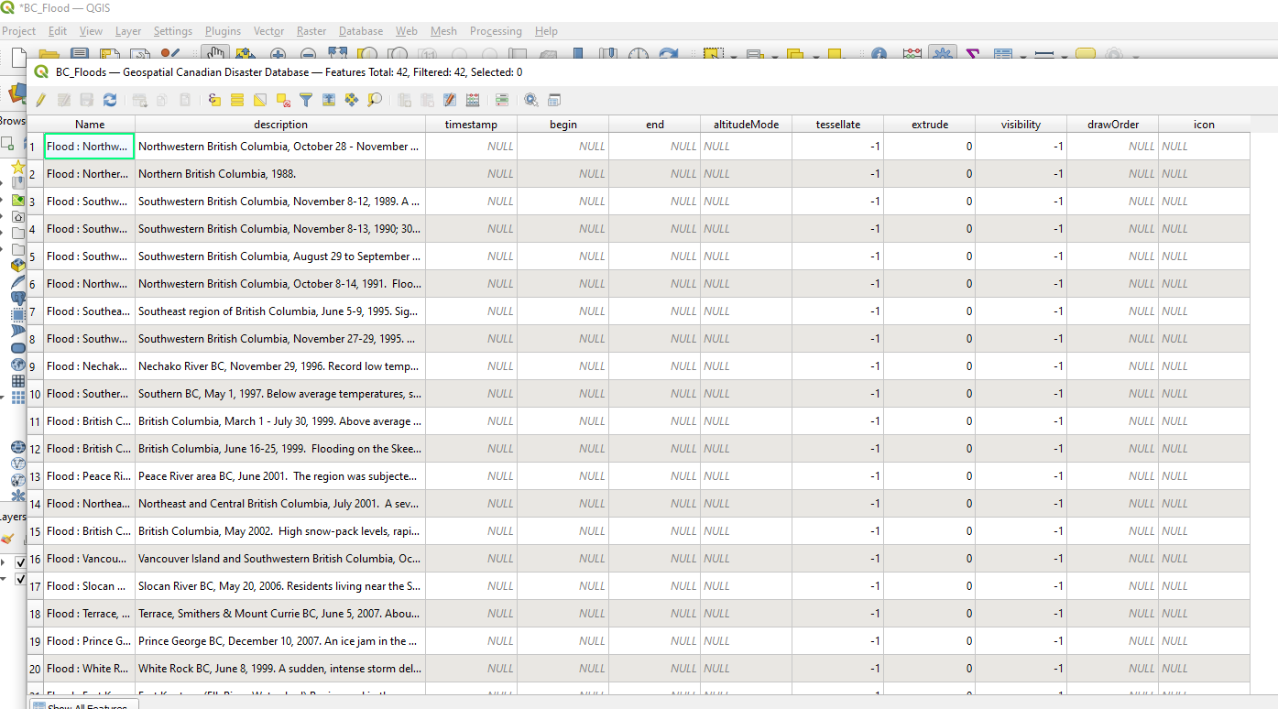

I wrote Jeff on this issue.

# Monday 22/11/28

I can’t figure out where to put $1 or more. Where should I put the $1.00 or more? I need more work from Jeff.

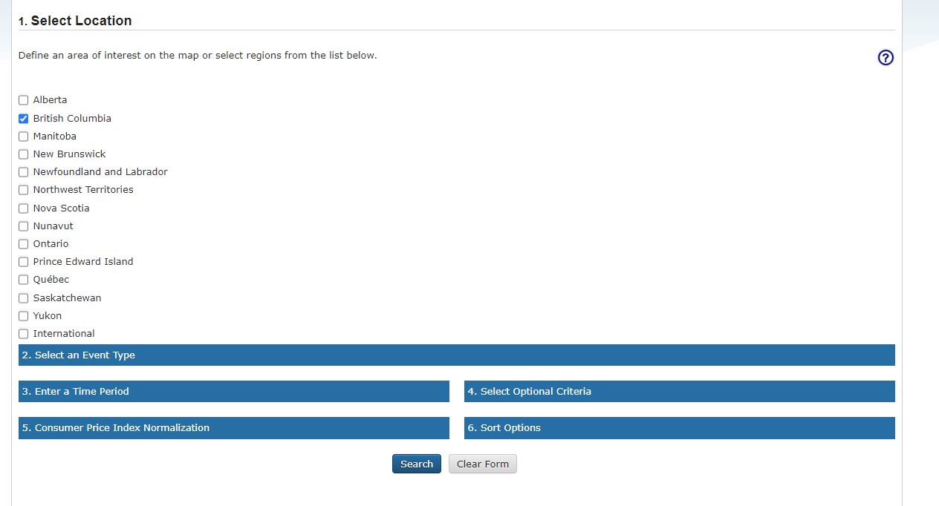

# Tuesday 22/11/29

I was guided by My twin sister Lili for the estimated cost and it still didn’t work. I preferred the email to my programmerani email as it is work related so I forwarded it to my Programmerani email myself. I took that file and opened it in notepad++ and saved it as a csv file. I then put it in QGIS and there were no lat and long so it didn’t show.

# Tuesday 22/12/05

I search up ways to display KML data in QGIS. My ArcGIS account didn’t let me in ArcGIS.

# Tuesday 22/12/06

I made a GIS Stack Exchange account and posted a question about displaying kml data.

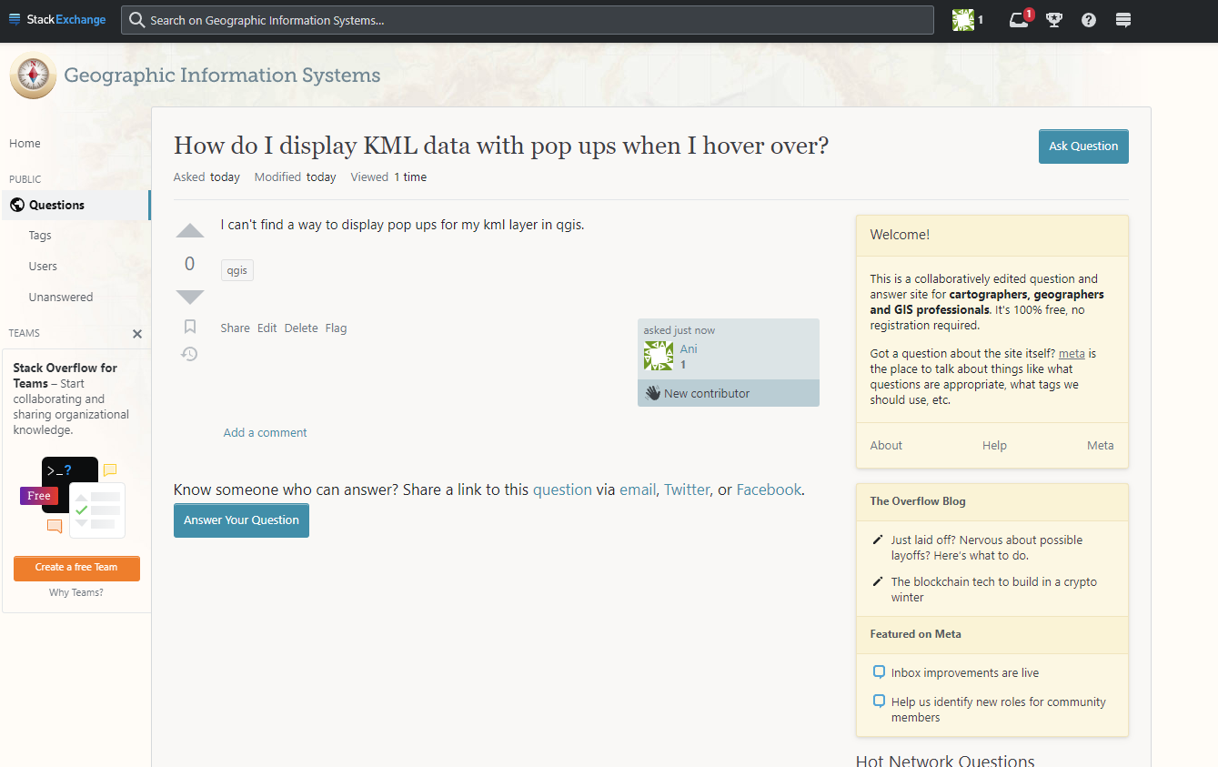

# Wednesday 22/12/07

My question was closed due to not enough details. I am still learning how to navigate the gis stack exchange. I edited my question and made it make more sense and it is being reviewed for reopening.

Question closed means that the question doesn’t make sense or has too little details and was put on hold.

Is it still under review? Or was your question able to be reposted once you updated with more details?

# Thursday 22/12/08

Try “how to add KML text data attribute to a base map in QGIS?”

My BC floods KML layer does not have a cost attribute.

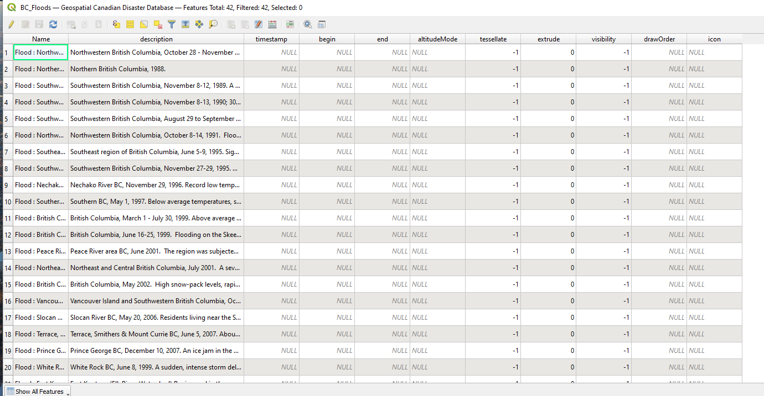

Found a way to show my map with pop ups. Look below.

I went into the plugins tab and installed qgis2web in QGIS.

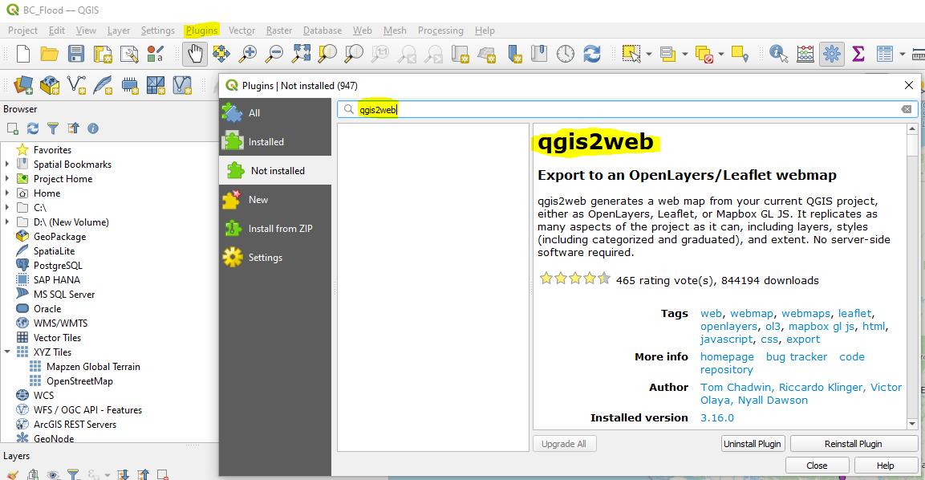

I clicked the web tab and clicked qgis2web and clicked create webmap.

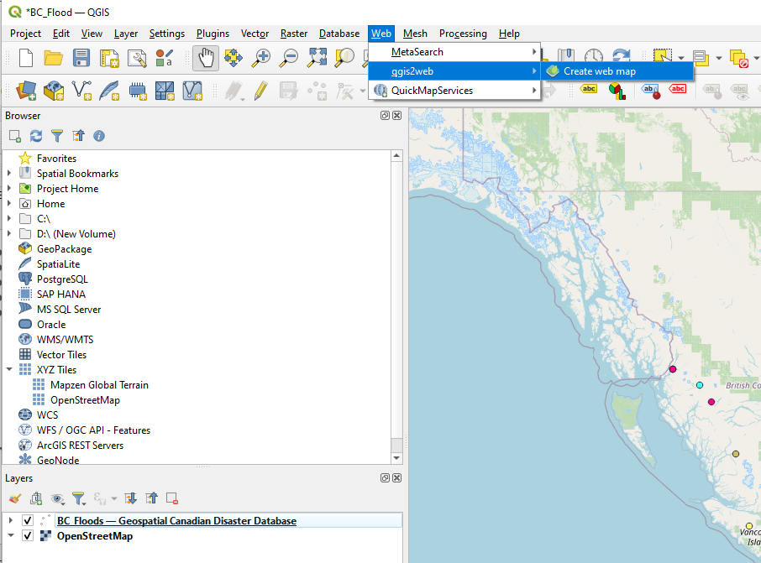

I played around in the create map window.

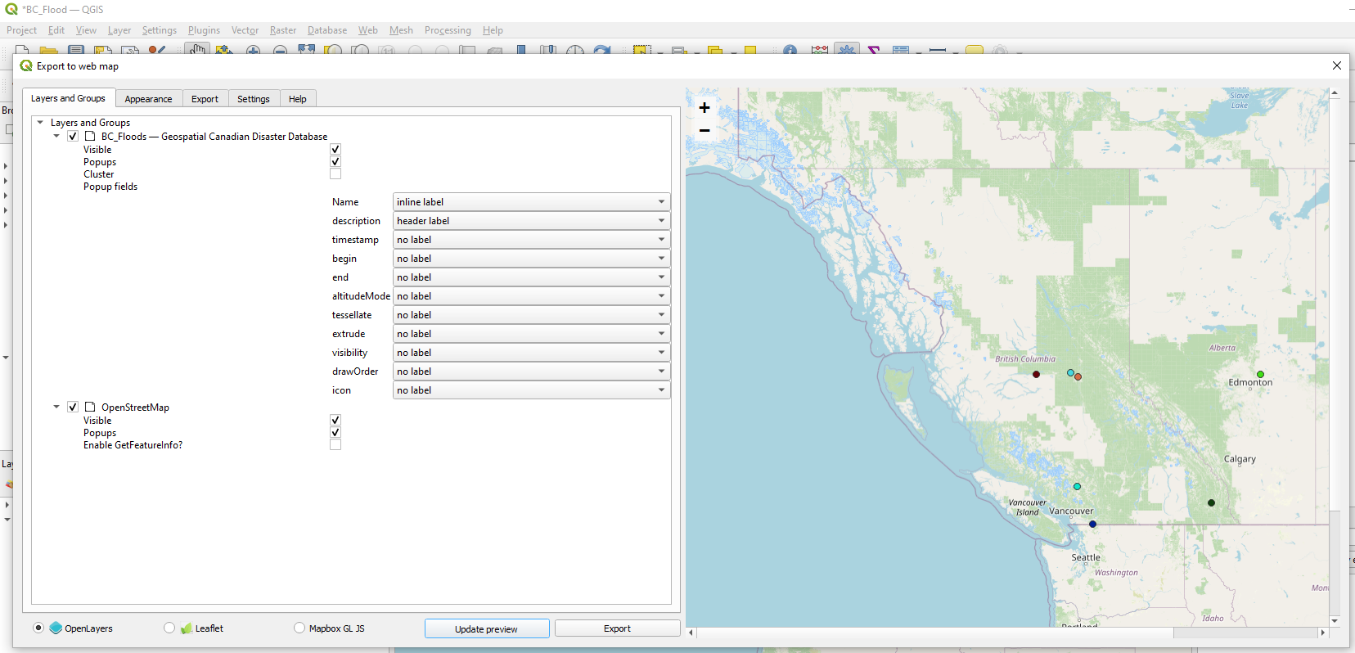

# Monday 22/12/12

I will play around in QGIS web map creation. I went onto the Australian flood risk portal and searched BC and nothing came up.

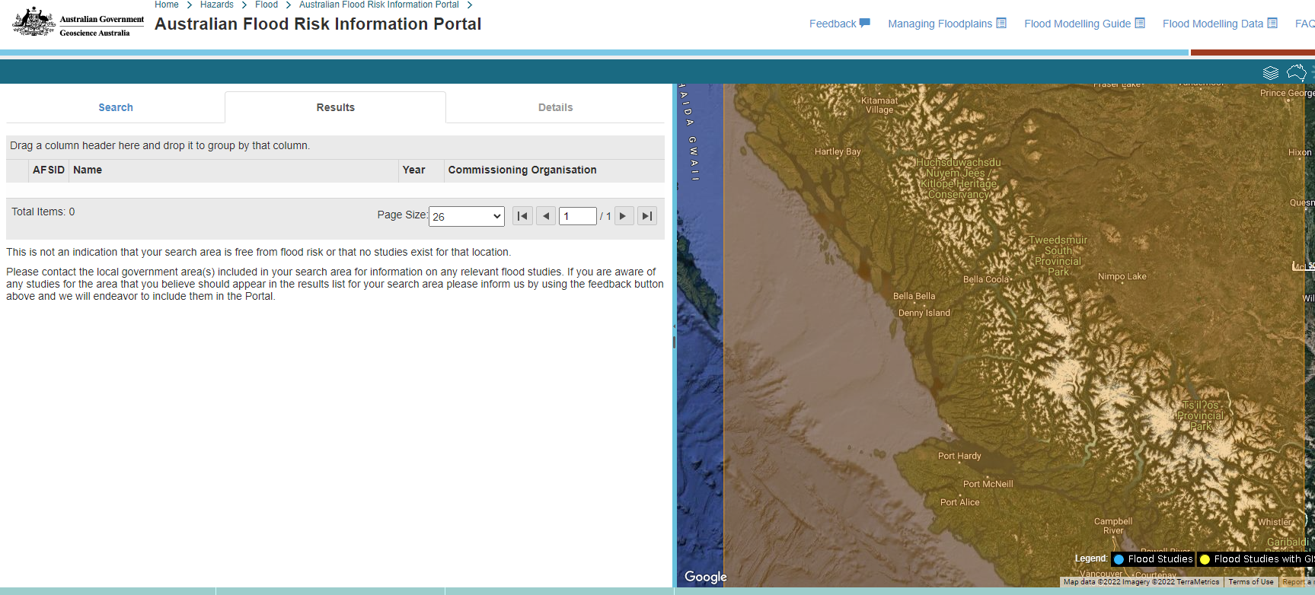

I found this by searching bc floods and this is what I found and I don’t know how to download it. Look below.

